

|  |  |
| --- | --- |
| **NAME** | **Tanvi Bahedia** |
| **REGISTER NUMBER** | 20BCE1667 |
| **COURSE** | CSE3002 INTERNET & WEB PROGRAMMING (IWP) |
| **DATE** | NOVEMBER 2, 2022 |
| **FACULTY** | Dr. V. Muthumanikandan |

###### INDEX

|  |  |
| --- | --- |
| **Lab No.** | **Page No.** |
| 1 | 1 |
| 2 | 8 |
| 3 | 17 |
| 4 | 30 |
| 5 | 39 |
| 6 | 43 |
| 7 | 59 |
| 8 | 71 |
| 9 | 76 |
| 10 | 84 |
| 11 | 87 |
| 12 | 97 |

***Date : 25-07-2022***

## Experiment #1

***AIM:*** To perform the given exercises in HTML with the use of notepad.

***PROCEDURE:***

1. Open Notepad.
2. Type the code.
3. Save the notepad file as ***filename.html***.
4. Open the file on any browser available.

CODE:

**lab1.html**

<html>

<head>

<title> My First Class </title>

</head>

<h1> IWP </h1>

<body>

<p>

<i>Let you all become expert in Web Programming</i>

</p>

<h2> LAB1 - Exercise </h2>

<hr>

<h3> i. </h3>

<font color = "green"> Tanvi Bahedia </font>

<h3> ii. </h3>

<p>

<font color = "violet"> 1 </font>

<font color = "indigo"> 2 </font>

<font color = "blue"> 3 </font>

<font color = "green"> 4 </font>

<font color = "yellow"> 5 </font>

<font color = "orange"> 6 </font>

<font color = "red"> 7 </font>

<font color = "pink"> 8 </font>

<font color = "dark blue"> 9 </font>

<font color = "dark yellow"> 10 </font>

</p>

<h3> iii. </h3>

<p>

<font face = "tahoma"> Tanvi Bahedia </font>

</p>

<h3> iv. </h3>

<p> TA<b><u>NV</b></u>I

</p>

<h3> v. </h3>

<p>

<font face = "tahoma"> Hello, I am Tanvi Bahedia. </font>

<font face = "times new roman"> I am from SCOPE. </font>

<font face = "arial"> I study in Vellore Institute of Technology. </font>

<font face = "calibri"> I am currently in my 3rd Year. </font>

</p>

<h3> vi. </h3>

<h4> Call me by your name </h4>

<h5> by André Aciman</h5>

<details>

<summary> Description of the book </Summary>

<p> <u>Call Me by Your Name (Italian: Chiamami col tuo nome)</u> is a 2017 coming-of-age <i>romantic</i> book. Its screenplay, by <u>James Ivory</u>, who also co-produced, is based on the 2007 novel of the same title by <u>André Aciman</u>.

The film is the final installment in <u>Guadagnino's</u> <i>thematic</i> "Desire" trilogy. Set in 1983 in northern <u>Italy</u>, <u>Call Me by Your Name </u> chronicles the

<i>romantic</i> relationship between a 17-year-old, <u>Elio Perlman (Timothée Chalamet) </u>, and <u>Oliver (Armie Hammer) </u>, a 24-year-old graduate-student assistant to <u>Elio's </u> father <u>Samuel (Michael Stuhlbarg) </u>, an archaeology professor.

</details>

<h3> vii. </h3>

<p>

<h1>T</h1>

<h2>A</h2>

<h3>N</h3>

<h4>V</h4>

<h5>I</h5>

</p>

<h3> viii. </h3>

You can't see the comment.

<!-- I wrote a comment but it is most probably not visible. -->

<h3> ix. </h3>

<p>

a<sup>2</sup>-b<sup>2</sup>=2ab

</p>

<h3> x. </h3>

<p> H<sub>2</sub>O

</p>

<h3> xi. </h3> #include <stdio.h>

<p>int main() {<wbr>

int number1, number2, sum;<br><br> printf("Enter two integers: ");<br>

scanf("%d %d", &number1, &number2);<br><br>

// calculating sum<br>

sum = number1 + number2; <br><br>

printf("%d + %d = %d", number1, number2, sum);<br> return 0;<br>

}

</p>

<h3> xii. </h3>

<p>

<a href="yellow.html"> Yellow BG Page</a>

</p>

<h3> xiii. </h3>

<p>

<a href="image.html"> Image BG Page</a>

</p>

<h3> xiv. </h3>

<p>

<font size = 10> Tanvi </font>

<font size = 5> Tanvi </font>

</p>

<h3> xv. </h3>

<p>

<marquee style="width:10px direction:right height:4px loop:10 bgcolor:grey"> Tanvi Bahedia</marquee>

</p>

<h3> xvi. </h3>

<p>

Hello, I am Tanvi Bahedia. I study in Vellore Institute of Technology. I am from SCOPE.

</p>

<h3> xvii. </h3>

<div style="border:5px solid purple;padding:10px;font-size:20px">

<p>This is paragraph 1. You can see Paragraph 2 too right?</p>

<p>This is paragraph 2. You can see Paragraph 1 too right?</p>

</div>

</body>

</html>

**yellow.html**

<html>

<head>

<title> Yellow </title>

</head>

<body bgcolor = "yellow">

</body>

</html>

**image.html**

<html>

<head>

<title> Image </title>

</head>

<body background =

"https://static.wikia.nocookie.net/the-bangtan-boys/images/1/12/BTS_Proof_Concept_P hoto_Proof_Version.jpg/revision/latest?cb=20220527150551">

</body>

</html>

OUTPUT:

***lab1.html***

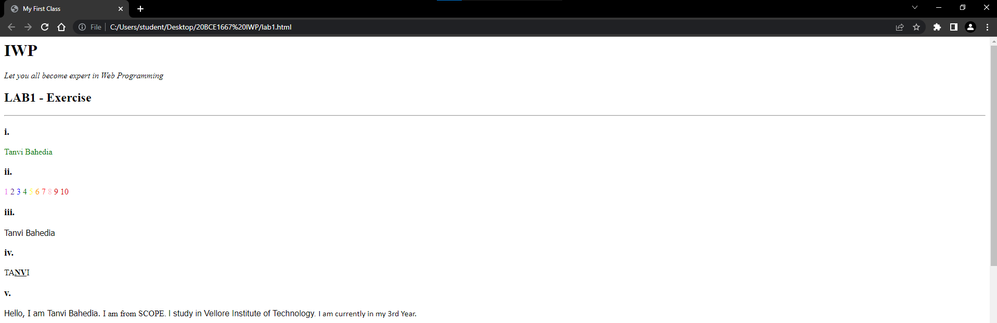

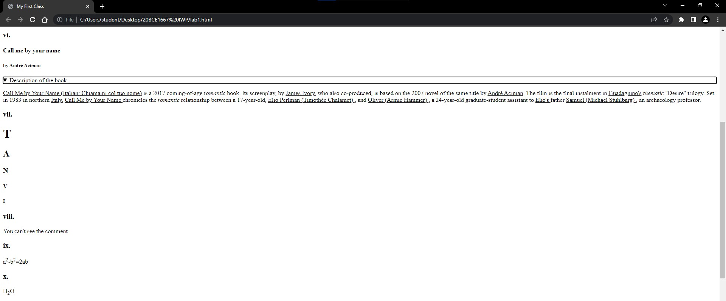

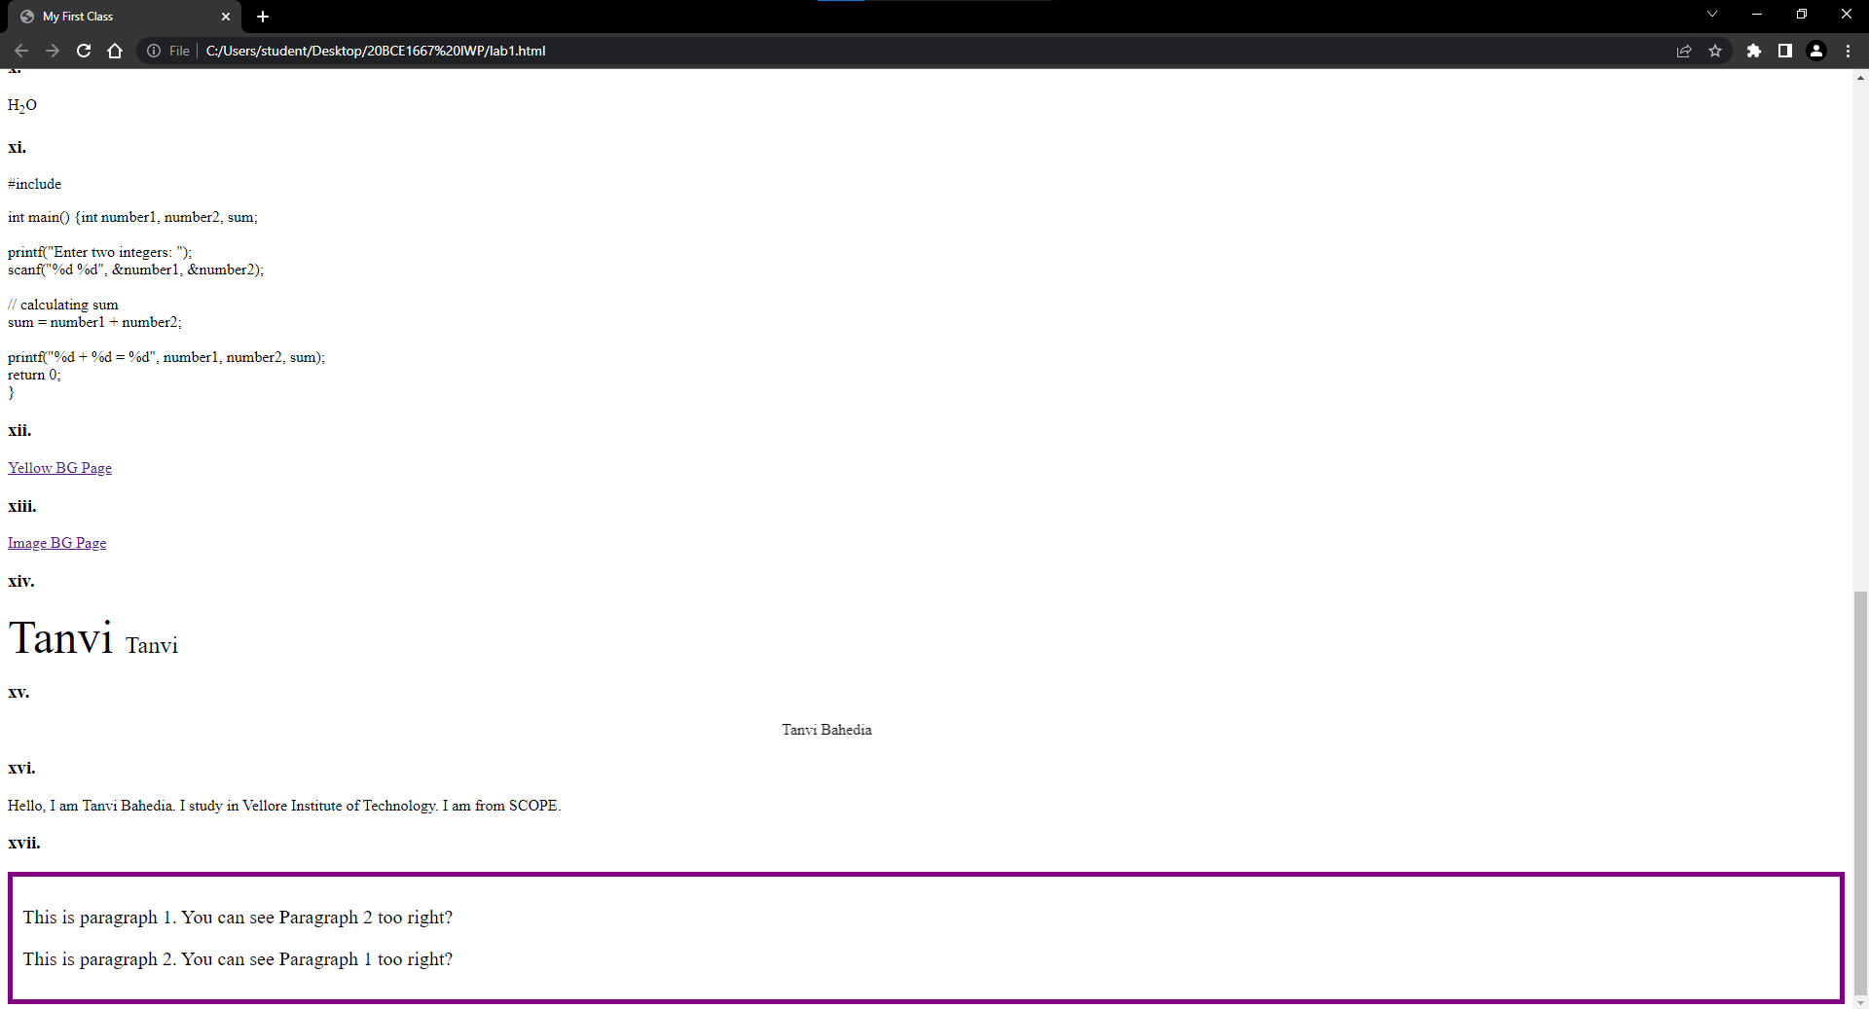

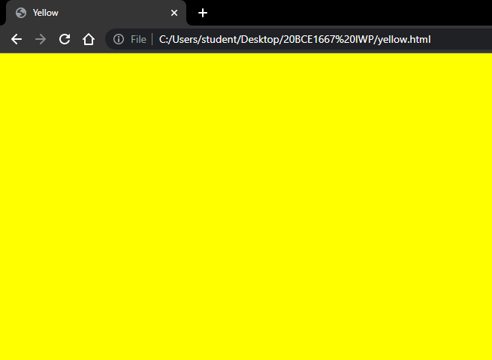***yellow.html***

***image.html***

RESULT:

We learned how to apply various Tags, Attributes and Elements in HTML.

***Date: 02-08-2022***

**EXPERIMENT #2**

***AIM:*** To learn more through the given exercises in HTML and CSS with the use of Atom Text Editor.

***PROCEDURE:***

1. Open Atom Text Editor.
2. Type the code.
3. Save the file as ***filename.html*** and link the styles in the html file.
4. Open the file on any browser available.

##### CODE:

*<!DOCTYPE html>*

*<html lang="en" dir="ltr">*

*<head>*

*<meta charset="utf-8">*

*<title></title>*

*</head>*

*<body>*

*<table cellpadding = 10 border = 1>*

*<tr>*

*<td> a.</td>*

*<td>*

*1<sup>2</sup> = 1<br> 2<sup>2</sup> = 4<br> 3<sup>2</sup> = 9<br> 4<sup>2</sup> = 16<br> 5<sup>2</sup> = 25<br> 6<sup>2</sup> = 36<br> 7<sup>2</sup> = 49<br> 8<sup>2</sup> = 64<br> 9<sup>2</sup> = 81<br> 10<sup>2</sup> = 100<br> 11<sup>2</sup> = 121<br> 12<sup>2</sup> = 144<br> 13<sup>2</sup> = 169<br>*

*14<sup>2</sup> = 196<br> 15<sup>2</sup> = 225<br> 16<sup>2</sup> = 256<br> 17<sup>2</sup> = 289<br> 18<sup>2</sup> = 324<br> 19<sup>2</sup> = 361<br> 20<sup>2</sup> = 400<br>*

*</td>*

*</tr>*

*<tr>*

*<td>b.</td>*

*<td>*

*<ul>*

*<li> <h5>Unalphabetized List</h5> </li>*

*<ol>*

*<li> Tanvi <sub>9</sub></li>*

*<li> Tanushree <sub>8</sub></li>*

*<li> Poulami <sub>5</sub></li>*

*<li> Yogesh <sub>10</sub></li>*

*<li> Gautam <sub>2</sub></li>*

*<li> Sparsh <sub>7</sub></li>*

*<li> Parkhi <sub>4</sub></li>*

*<li> Rani <sub>6</sub></li>*

*<li> Alka <sub>1</sub></li>*

*<li> Kamlesh <sub>3</sub></li>*

*</ol>*

*<li><h5> Alphabetized List </h5></li>*

*<ol>*

*<li> Alka </li>*

*<li> Gautam </li>*

*<li> Kamlesh </li>*

*<li> Parkhi </li>*

*<li> Poulami </li>*

*<li> Rani </li>*

*<li> Sparsh </li>*

*<li> Tanushree </li>*

*<li> Tanvi </li>*

*<li> Yogesh </li>*

*</ol>*

*</ul>*

*</td>*

*</tr>*

*<tr>*

*<td>c.</td>*

*<td>*

*<ol>*

*<li>Web Dev</li>*

*<li>Computers</li>*

*<li>Algebra</li>*

*</ol>*

*<br>*

*<ul>*

*<li>Psychology</li>*

*<li>Gaming</li>*

*<li>User Experience</li>*

*</ul>*

*</td>*

*</tr>*

*<tr>*

*<td>d.</td>*

*<td>*

*<ol start="7" type="i">*

*<li>Hello</li>*

*<li>Annyeong</li>*

*<li>Bonjour</li>*

*</ol>*

*</td>*

*</tr>*

*<tr>*

*<td>e.</td>*

*<td>*

*<h1> HELLO WORLD </h1>*

*<hr style="width:100%;">*

*<p>*

*Hello, World, I am Tanvi. Who are you? I am fine, very very thank you.*

*What you do you think about me? Oh, I don't know why do I sound so Fancy.*

*</p>*

*</td>*

*</tr>*

*<tr>*

*<td>f.</td>*

*<td>*

*<dl>*

*<dt>India</dt>*

*<dd>Capital of India is: New Delhi.</dd>*

*<dt>South Korea</dt>*

*<dd>Capital of South Korea is: Seoul.</dd>*

*<dt>United States of America</dt>*

*<dd>Capital of United States of America is: Washington DC.</dd>*

*<dt>United Arab Emirates</dt>*

*<dd>Capital of United Arab Emirates is: Abu Dhabi.</dd>*

*<dt>Nepal</dt>*

*<dd>Capital of Nepal is: Kathmandu.</dd>*

*</dl>*

*</td>*

*</tr>*

*<tr>*

*<td>g.</td>*

*<td>*

*D-1302, Mahindra Windchimes Apartment<br>Bannerghatta Road,Bangalore<br>Karnataka - 560076<br>*

*<center>Vellore Institute of Technology, Chennai<br>Girls Hostel, Chennai<br>Tamil Nadu - 600127</center>*

*</td>*

*</tr>*

*<tr>*

*<td>h.</td>*

*<td>*

*<acronym title="Bangtan Sonyeondan">BTS</acronym><br><br>*

*<acronym title="Korean Pop">K-pop</acronym><br><br>*

*<acronym title="Born to Beat">BtoB</acronym><br><br>*

*<acronym title="Indian Rupees">INR</acronym><br><br>*

*<acronym title="Indian Railway Catering and Tourism Corporation">IRCTC</acronym><br><br>*

*<acronym title="Laugh Out Loud">LOL</acronym><br><br>*

*<acronym title="Talk to you later">TTYL</acronym><br><br>*

*<acronym title="Good Game">GG</acronym><br><br>*

*<acronym title="Got to go">GTG</acronym><br><br>*

*<acronym title="Original Poster">OP</acronym><br><br>*

*</td>*

*</tr>*

*<tr>*

*<td>i.</td>*

*<td>*

*<figure>*

*<img*

*src="https://about.canva.com/wp-content/uploads/sites/8/2019/03/purple.png" alt="Purple" width="42" height="42">*

*<figcaption>Purple</figcaption><br><br>*

*<img*

*src="https://about.canva.com/wp-content/uploads/sites/8/2019/03/dark-blue.png" alt="Purple" width="42" height="42">*

*<figcaption>Blue</figcaption><br><br>*

*<img*

*src="https://about.canva.com/wp-content/uploads/sites/8/2019/03/orange.png" alt="Purple" width="42" height="42">*

*<figcaption>Orange</figcaption><br><br>*

*<img*

*src="https://about.canva.com/wp-content/uploads/sites/8/2019/03/green.png" alt="Purple" width="42" height="42">*

*<figcaption>Green</figcaption><br><br>*

*<img*

*src="https://about.canva.com/wp-content/uploads/sites/8/2019/03/black.png" alt="Purple" width="42" height="42">*

*<figcaption>Black</figcaption><br><br>*

*</figure>*

*</td>*

*</tr>*

*<tr>*

*<td>j. </td>*

*<td>*

*<img*

*src=*[*"https://www.pinkvilla.com/imageresize/j-hope_proof_main_0.jpg?width=752&format*](http://www.pinkvilla.com/imageresize/j-hope_proof_main_0.jpg?width=752&format)

*=webp&t=pvorg" alt="Jhope" border=2 width=200 height=200 align="right">*

*</td>*

*</tr>*

*</body>*

*</html>*

##### OUTPUT:

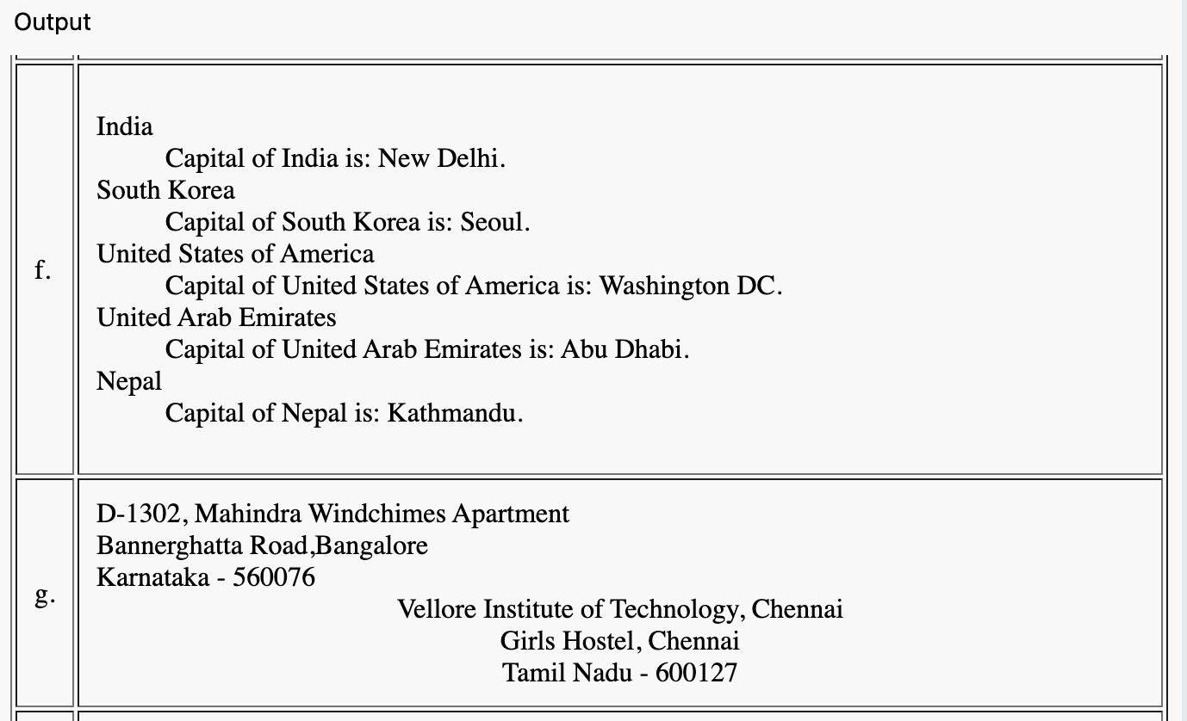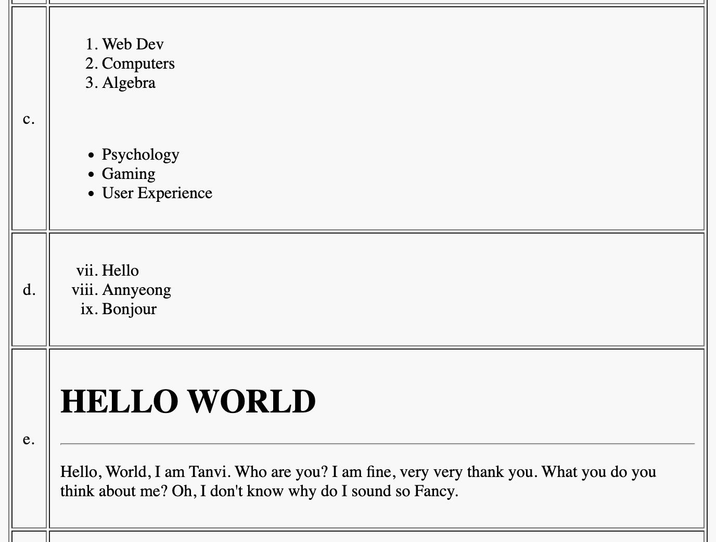

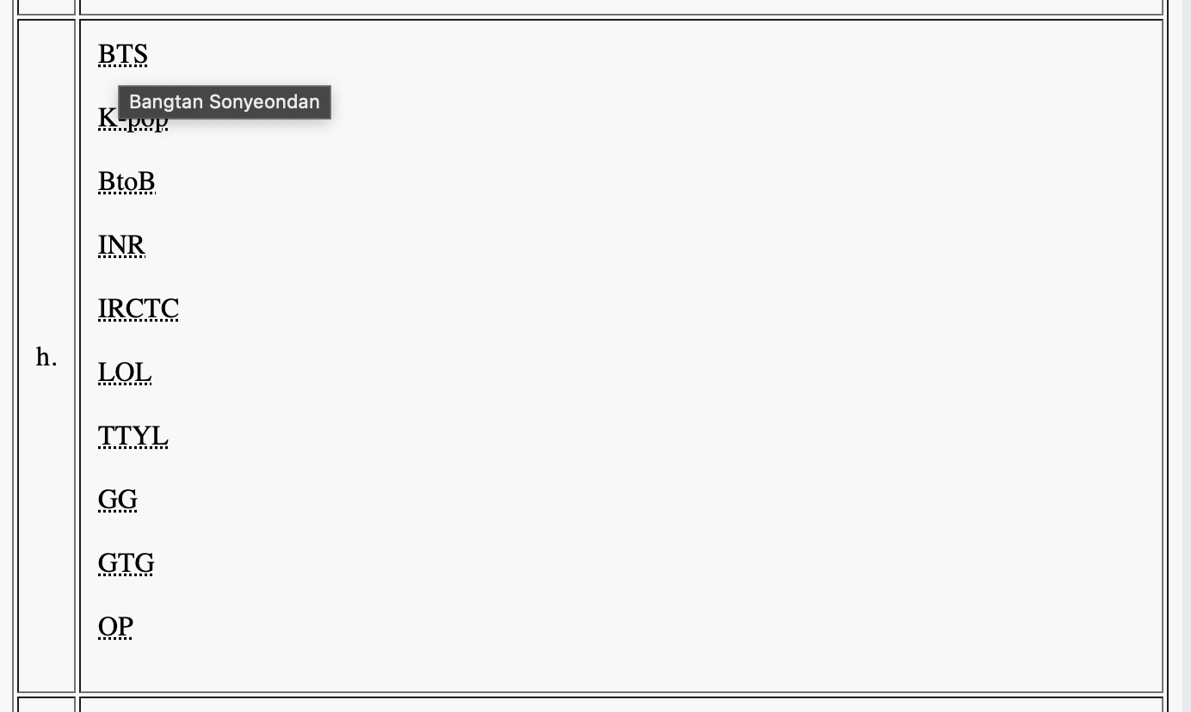

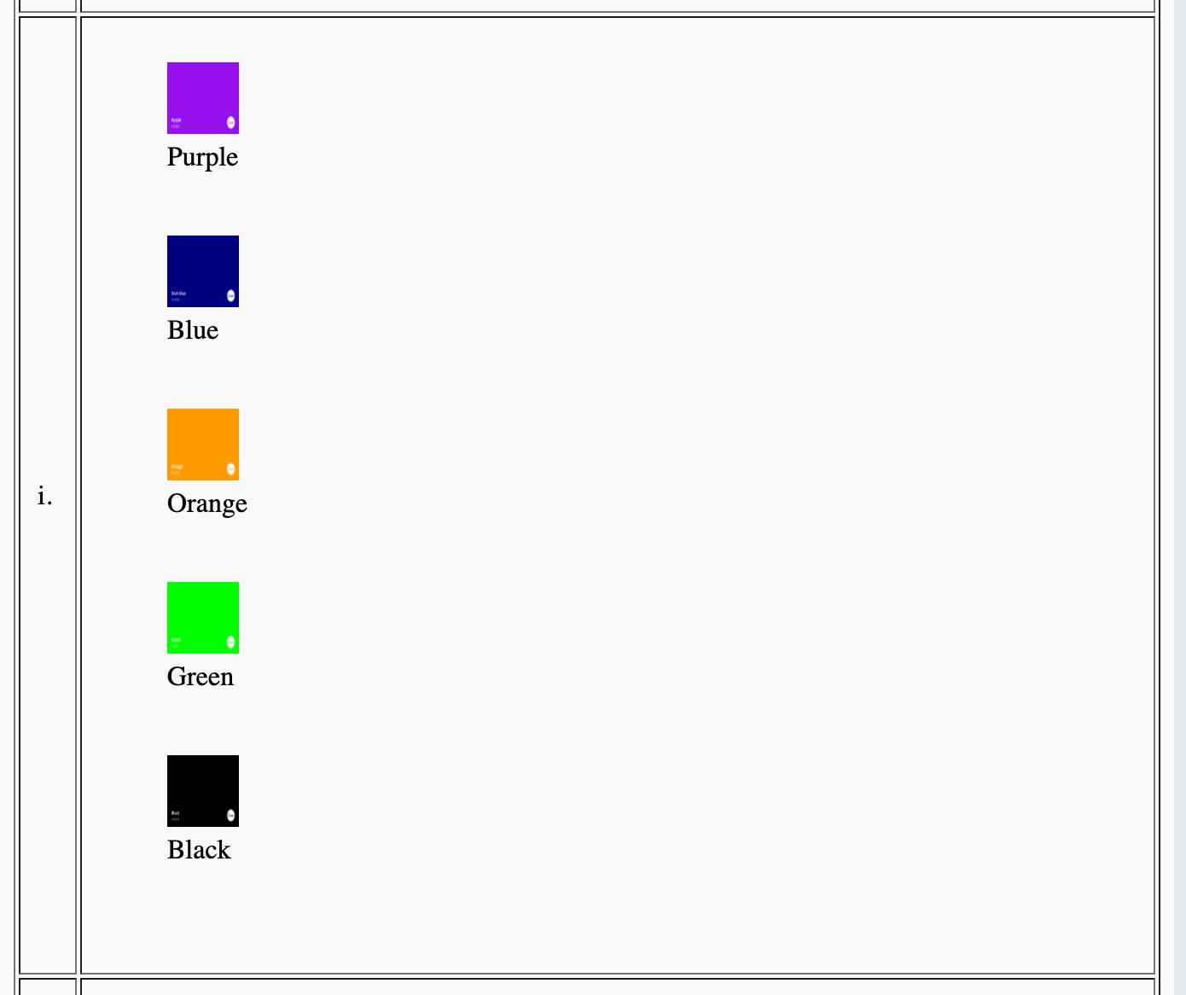

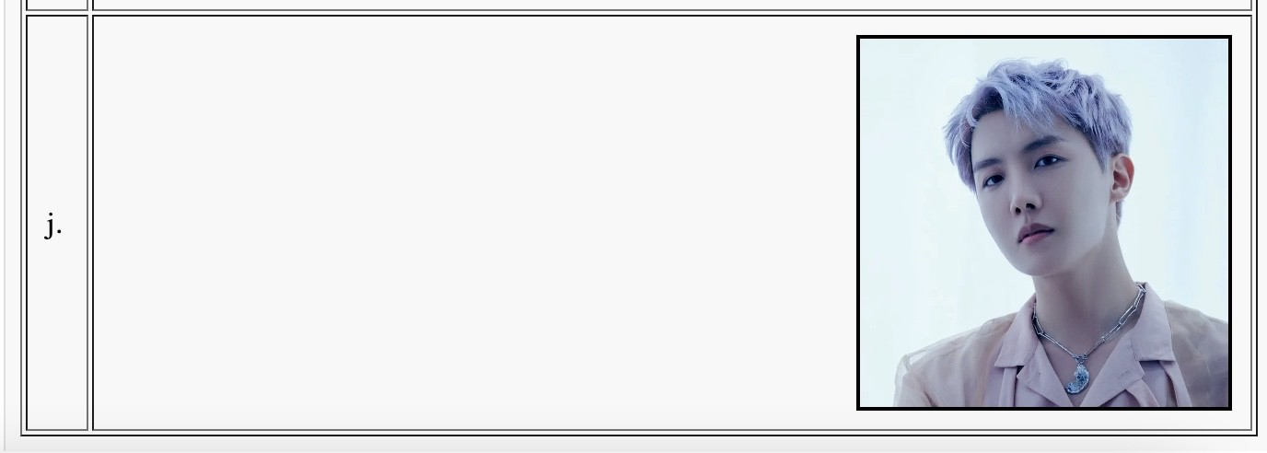

***RESULT:***

We learned how to apply various Tags, Attributes and Elements in HTML.

***Date : 25-07-2022***

## Experiment #1

***AIM:*** To make a simple website using HTML, CSS and inline JavaScript.

***PROCEDURE:***

1. Open Notepad.
2. Type the code.
3. Save the notepad file as ***filename.html*** or ***filename.css***.
4. Open the file on any browser available.

CODE:

***index.html***

<!DOCTYPE html>

<html lang="en" dir="ltr">

<head>

<meta charset="utf-8">

<title>K-Drama</title>

<link rel="icon" type="image/x-icon"

href="https://emoji-uc.akamaized.net/orig/14/3049770cef174349e665ae0f7485d1.png">

<link rel="stylesheet" href="styles.css">

</head>

<body>

<center><h1><abbr title="Korean Drama World">K-Drama World</abbr></h1><br></center>

<center>

<div class="navbar">

<a href="index.html" data-text="home">Home</a>

<a href="actors.html" data-text="actors">Actors</a>

<a href="genre.html" data-text="genres">Genres</a>

<a href="feedback.html" data-text="feedback">Feedback</a>

<a href="about.html" data-text="about">About</a>

</div>

</center> <hr />

<h2><center>

The purpose of this site is to get all the <br>K-Drama lovers together and let them have <br>

a lot of fun while watching and discussing and<br> knowing about thier favorite actors.<br><br>

</center></body></h2>

<span class="dot1"></span>

<span class="dot2"></span>

<span class="dot3"></span>

<span class="dot4"></span>

<span class="dot5"></span>

<span class="dot6"></span>

</body>

</html>

**actors.html**

<!DOCTYPE html>

<html lang="en" dir="ltr">

<head>

<meta charset="utf-8">

<title>Actors</title>

<link rel="icon" type="image/x-icon"

href="https://emoji-uc.akamaized.net/orig/15/9190b6067010c1921ad4512914095d.png">

<link rel="stylesheet" href="actors_style.css">

</head>

<body>

<center><h1>Actors</h1><br></center>

<div class="navbar">

<a href="index.html">Home</a>

<a href="https://ling-app.com/ko/korean-actors/">Popular-Today</a>

<a href="https://news.naver.com/">News</a>

</div><br>

<div class="blocks">

<center> <a href="https://en.wikipedia.org/wiki/Yeo_Jin-goo"><img src="https://asianwiki.com/images/d/da/Yeo_Jin-Goo-The_Long_Way_Home-GV.jpg" alt="Yeo Jin Goo"></a>

<h3>Yeo Jin Goo</h3><br>

</div></center>

<div class="blocks">

<center> <a href="https://en.wikipedia.org/wiki/Park_Bo-young"><img src="https://upload.wikimedia.org/wikipedia/commons/2/28/151003_%EB%B6%80%EC%82%B0%EA%B5%AD%EC

%A0%9C%EC%98%81%ED%99%94%EC%A0%9C_%EB%8F%8C%EC%97%B0%EB%B3%80%EC%9D%B4_%E C%95%BC%EC%99%B8_%EB%AC%B4%EB%8C%80%EC%9D%B8%EC%82%AC_%28Park_Bo-young%29.jpg"

alt="Park Bo Young"></a>

<h3>Park Bo Young</h3><br>

</div></center>

<div class="blocks">

<center> <a href="https://en.wikipedia.org/wiki/Lee_Jong-suk"><img src="https://upload.wikimedia.org/wikipedia/commons/2/2e/Lee_Jong-suk_March_2018.png" alt="Lee Jong Suk"></a>

<h3>Lee Jong Suk</h3><br>

</div></center>

<div class="blocks">

<center> <a href="https://en.wikipedia.org/wiki/Lee_Sung-kyung"><img src="https://upload.wikimedia.org/wikipedia/commons/0/07/Lee_Sung-kyung_on_October_18%2C_2019_at_Jimmy_ Choo_event_02.jpg" alt="Lee Sung Kyung"></a>

<h3>Lee Sung Kyung</h3><br>

</div></center>

<div class="blocks">

<center> <a href="https://en.wikipedia.org/wiki/Kim_Min-jae_(actor,_born_1996)"><img src="https://thetalkingcupboard.files.wordpress.com/2020/02/kimminjae_grazia_feb20_1.jpg" alt="Kim Min Jae"></a>

<h3>Kim Min Jae</h3><br>

</div></center>

<div class="blocks">

<center> <a href="https://en.wikipedia.org/wiki/Park_Gyu-young"><img src="https://upload.wikimedia.org/wikipedia/commons/4/41/Park_Kyu-young_2019%282%29.png" alt="Park Kyu Young"></a>

<h3>Park Gyu Young</h3><br>

</div></center>

<div class="blocks">

<center> <a href="https://en.wikipedia.org/wiki/Song_Joong-ki"><img src="https://upload.wikimedia.org/wikipedia/commons/thumb/1/13/Song_Joong-ki_at_Style_Icon_Asia_2016.jpg/440p x-Song_Joong-ki_at_Style_Icon_Asia_2016.jpg" alt="Park Bo Young"></a>

<h3>Song Joong Ki</h3><br>

</div></center>

<div class="blocks">

<center> <a href="https://en.wikipedia.org/wiki/Jeon_Yeo-been"><img src="https://upload.wikimedia.org/wikipedia/commons/9/95/Jeon_Yeobin_2021.jpg" alt="Jeon Yeo Bin"></a>

<h3>Jeon Yeo Bin</h3><br>

</div></center>

<div class="blocks">

<center> <a href="https://en.wikipedia.org/wiki/Bae_Suzy"><img src="https://upload.wikimedia.org/wikipedia/commons/thumb/9/97/180503_%EC%88%98%EC%A7%80_01.jpg/1024 px-180503_%EC%88%98%EC%A7%80_01.jpg" alt="Jeon Yeo Bin"></a>

<h3>Bae Suzy</h3><br>

</div></center><br>

<div class="tiny">

<center> <a href="https://mydramalist.com/" target="_blank">etc...</a>

</div></center>

</body>

</html>

**genre.html**

<!DOCTYPE html>

<html lang="en" dir="ltr">

<head>

<meta charset="utf-8">

<title>Genres</title>

<link rel="icon" type="image/x-icon"

href="https://emoji-uc.akamaized.net/orig/15/9190b6067010c1921ad4512914095d.png">

<link rel="stylesheet" href="actors_style.css">

</head>

<body>

<center><h1>Genres</h1><br></center>

<div class="navbar">

<a href="index.html">Home</a>

<a href="https://news.naver.com/" target="Here">Latest Release</a>

<div class="dropdown">

<button class="dropbtn">More

<i class="fa fa-caret-down"></i>

</button>

<div class="dropdown-content">

<a href="https://koreanlovey.com/2022/03/13/rom-com-korean-dramas-of-2022/" target="Here" onclick="openEditProfile()">Romantic</a>

<a

[href="http://www.alphagirlreviews.com/16-best-comedy-korean-dramas-to-watch-when-you-need-a-laughter-break/"](http://www.alphagirlreviews.com/16-best-comedy-korean-dramas-to-watch-when-you-need-a-laughter-break/) target="Here">Comedy</a>

<a href="https://thesmartlocal.com/korea/thriller-korean-dramas/" target="Here">Thriller</a>

<a href="https://screenrant.com/highest-rated-kdramas-imdb/" target="Here">Medical</a>

<a href="https://koreanlovey.com/2022/03/18/top-korean-dramas-based-on-military/" target="Here">Military</a>

<a href="https://koreanlovey.com/2022/08/10/historical-korean-dramas-of-2022/" target="Here">Historical</a>

</div>

</div>

</div><br><br>

<center>

<iframe name="Here" width=90% height=500px style="border:none"></iframe>

</script>

</center>

</body>

</html>

**feedback.html**

<!DOCTYPE html>

<html lang="en" dir="ltr">

<head>

<meta charset="utf-8">

<title>Feedback</title>

<link rel="icon" type="image/x-icon"

href="https://emoji-uc.akamaized.net/orig/3d/c0bfc28ef2db2eebf66879a2dc37ea.png">

<link rel="stylesheet" href="styles.css">

</head>

<body>

<center><h1>Feedback</h1></center>

<div class="navbar">

<a href="index.html">Home</a>

</div><br><br />

<h3>

<form id="form1" action="index.html" method="post">

<label for="name">Name:</label><br>

<input type="text" id="name" name="name" value="-Your name-"><br /><br>

<label for="mail">E-Mail:</label><br>

<input type="email" id="mail" name="mail" value="-Your email-"><br><br>

<label for="feedback">Feedback:</label><br>

<textarea name="feedback" rows="10" cols="50">-Your feedback-</textarea><br>

</form></h3>

<button onclick=validateForm()>Submit</button>

<script>

function validateForm()

{

let x = document.forms["form1"]["name"].value; let y = document.forms["form1"]["mail"].value;

var mailformat = /^([a-zA-Z0-9_\.\-])+\@(([a-zA-Z0-9\-])+\.)+([a-zA-Z0-9]{2,4})+$/; if(y.match(mailformat) && x!="")

{

alert("Submitted Successfully"); return true;

}

else

{

alert("Invalid Inputs!"); return false;

}

}

</script>

</body>

</html>

**about.html**

<!DOCTYPE html>

<!--Dt7520$a-->

<html lang="en" dir="ltr">

<head>

<meta charset="utf-8">

<title>About</title>

<link rel="icon" type="image/x-icon"

href="https://d3ml8cfhn9inlg.cloudfront.net/wp-content/uploads/2018/08/Screen-Shot-2018-08-01-at-3.00.33-PM-800 x796.png">

<link rel="stylesheet" href="styles.css">

</head>

<body>

<center><h1>About</h1>

<hr><br></center>

<div class="navbar">

<a href="index.html">Home</a>

</div>

<h3><center>

The purpose of this site is to get all the <br>K-Drama lovers together and let them have <br>

a lot of fun while watching and discussing and<br> knowing about thier favorite actors.<br><br>

</center></body></h3>

<span class="dot1"></span>

<span class="dot2"></span>

<span class="dot3"></span>

<span class="dot4"></span>

<span class="dot5"></span>

<span class="dot6"></span>

</body>

</html>

**actors_style.css**

/* Navbar container */

.navbar { overflow: hidden;

background-color: #e4a0a0; font-family: Arial;

}

body {

background-color: #94b4d0; color: #f6f4f4;

font-family: Trebuchet MS;

}

/* Links inside the navbar */

.navbar a { float: left;

font-size: 16px; color: white;

text-align: center; padding: 14px 30px;

text-decoration: none;

}

/* The dropdown container */

.dropdown { float: left;

overflow: hidden;

}

/* Dropdown button */

.dropdown .dropbtn { font-size: 16px; border: none; outline: none; color: white;

padding: 14px 40px; background-color: inherit;

font-family: inherit; /* Important for vertical align on mobile phones */ margin: 0; /* Important for vertical align on mobile phones */

}

/* Add a #f0d2d2 background color to navbar links on hover */

.navbar a:hover, .dropdown:hover .dropbtn { background-color: #f0d2d2;

}

/* Dropdown content (hidden by default) */

.dropdown-content { display: none; position: absolute;

background-color: #e4a0a0; min-width: 160px;

box-shadow: 0px 8px 16px 0px rgba(0,0,0,0.2); z-index: 1;

}

/* Links inside the dropdown */

.dropdown-content a { float: none;

color: #f6f4f4; padding: 12px 16px; text-decoration: none; display: block;

text-align: left;

}

/* Add a grey background color to dropdown links on hover */

.dropdown-content a:hover { background-color: #ddd;

}

/* Show the dropdown menu on hover */

.dropdown:hover .dropdown-content { display: block;

}

.blocks {

background-color: rgb(246, 244, 244, 0.3); height: 420px;

width: 300px;

align-content: center; display:inline-block; margin: 0.5%;

margin-inline-start: 20px; margin-inline-end: 20px; border-color: #f6f4f4; border-style: dotted; border-radius: 10%; padding: 10px;

box-shadow: #e4a0a0; border-width: 5px;

}

.tiny {

background-color: rgb(246, 244, 244, 0.3); height: 30px;

width: 80px;

align-content: center; border-color: #f6f4f4; border-style: dotted; border-radius: 10%; padding: 10px;

box-shadow: #e4a0a0; border-width: 5px;

}

img{

height: 360px; width: 280px; border-radius: 10%;

}

**style.css**

body {

background-color: #94b4d0; color: #f6f4f4;

font-family: Trebuchet MS;

}

hr {

width: 6%;

border: 2px dashed #f6f4f4; border-radius: 5px;

}

a:link, a:visited { color: #f6f4f4; padding: 14px 40px;

text-align: center;

text-decoration: none; display: inline-block;

}

a:hover, a:active { background-color: #cfe2f3;

}

.navbar { overflow: hidden;

background-color: #e4a0a0; font-family: Arial;

}

.navbar a:hover, .dropdown:hover .dropbtn { background-color: #f0d2d2;

}

.dot1{

width: 15px; height: 15px;

background-color: rgb(234, 151, 144);

border-radius: 50%; animation-name: mymove; display: inline-block;

animation: mymove 15s infinite; position: relative;

}

@keyframes mymove { from {left: 0%;}

to {left: 100%;}

0% {background-color: #f0cd86;}

10% {background-color: rgb(234, 234, 146);}

20% {background-color: rgb(156, 239, 133);}

30% {background-color: rgb(152, 241, 223);}

40% {background-color: rgb(152, 192, 241);}

50% {background-color: rgb(152, 165, 241);}

60% {background-color: rgb(207, 152, 241);}

70% {background-color: rgb(241, 152, 208);}

80% {background-color: rgb(241, 152, 152);}

90% {background-color: rgb(241, 232, 152);}

100% {background-color: rgb(123, 221, 236);}

}

.dot2 {

width: 15px; height: 15px;

background-color: rgb(234, 151, 144);

border-radius: 50%; animation-name: mymove; display: inline-block;

animation: mymove 15.5s infinite; position: relative;

}

.dot3 {

width: 15px; height: 15px;

background-color: rgb(234, 151, 144);

border-radius: 50%; animation-name: mymove; display: inline-block;

animation: mymove 16s infinite; position: relative;

}

.dot4 {

width: 15px; height: 15px;

background-color: rgb(234, 151, 144);

border-radius: 50%; animation-name: mymove; display: inline-block;

animation: mymove 16.5s infinite; position: relative;

}

.dot5 {

width: 15px; height: 15px;

background-color: rgb(234, 151, 144);

border-radius: 50%; animation-name: mymove; display: inline-block;

animation: mymove 17s infinite; position: relative;

}

.dot6 {

width: 15px; height: 15px;

background-color: rgb(234, 151, 144);

border-radius: 50%; animation-name: mymove; display: inline-block;

animation: mymove 17.5s infinite; position: relative;

}

OUTPUT:

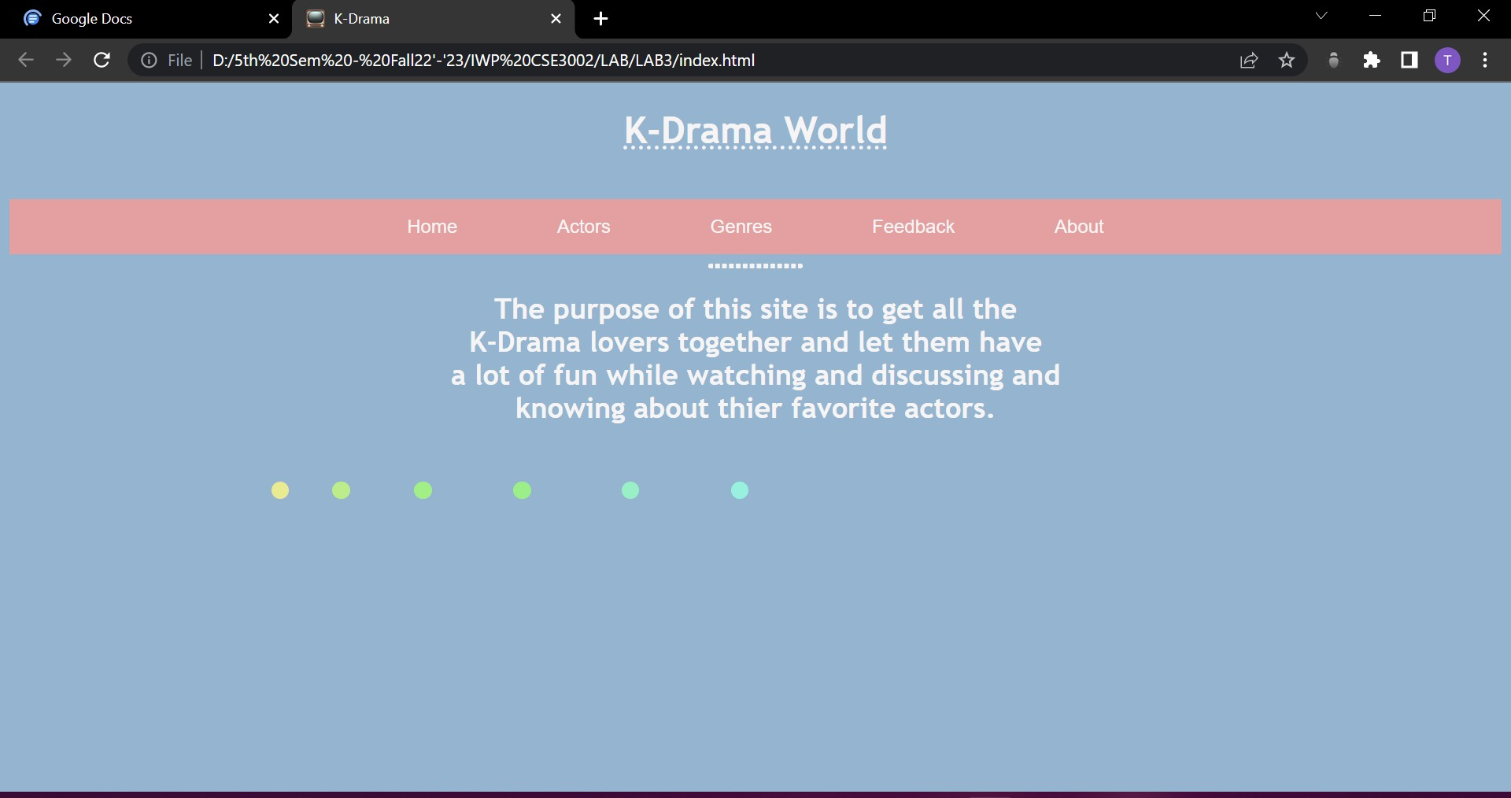***index.html***

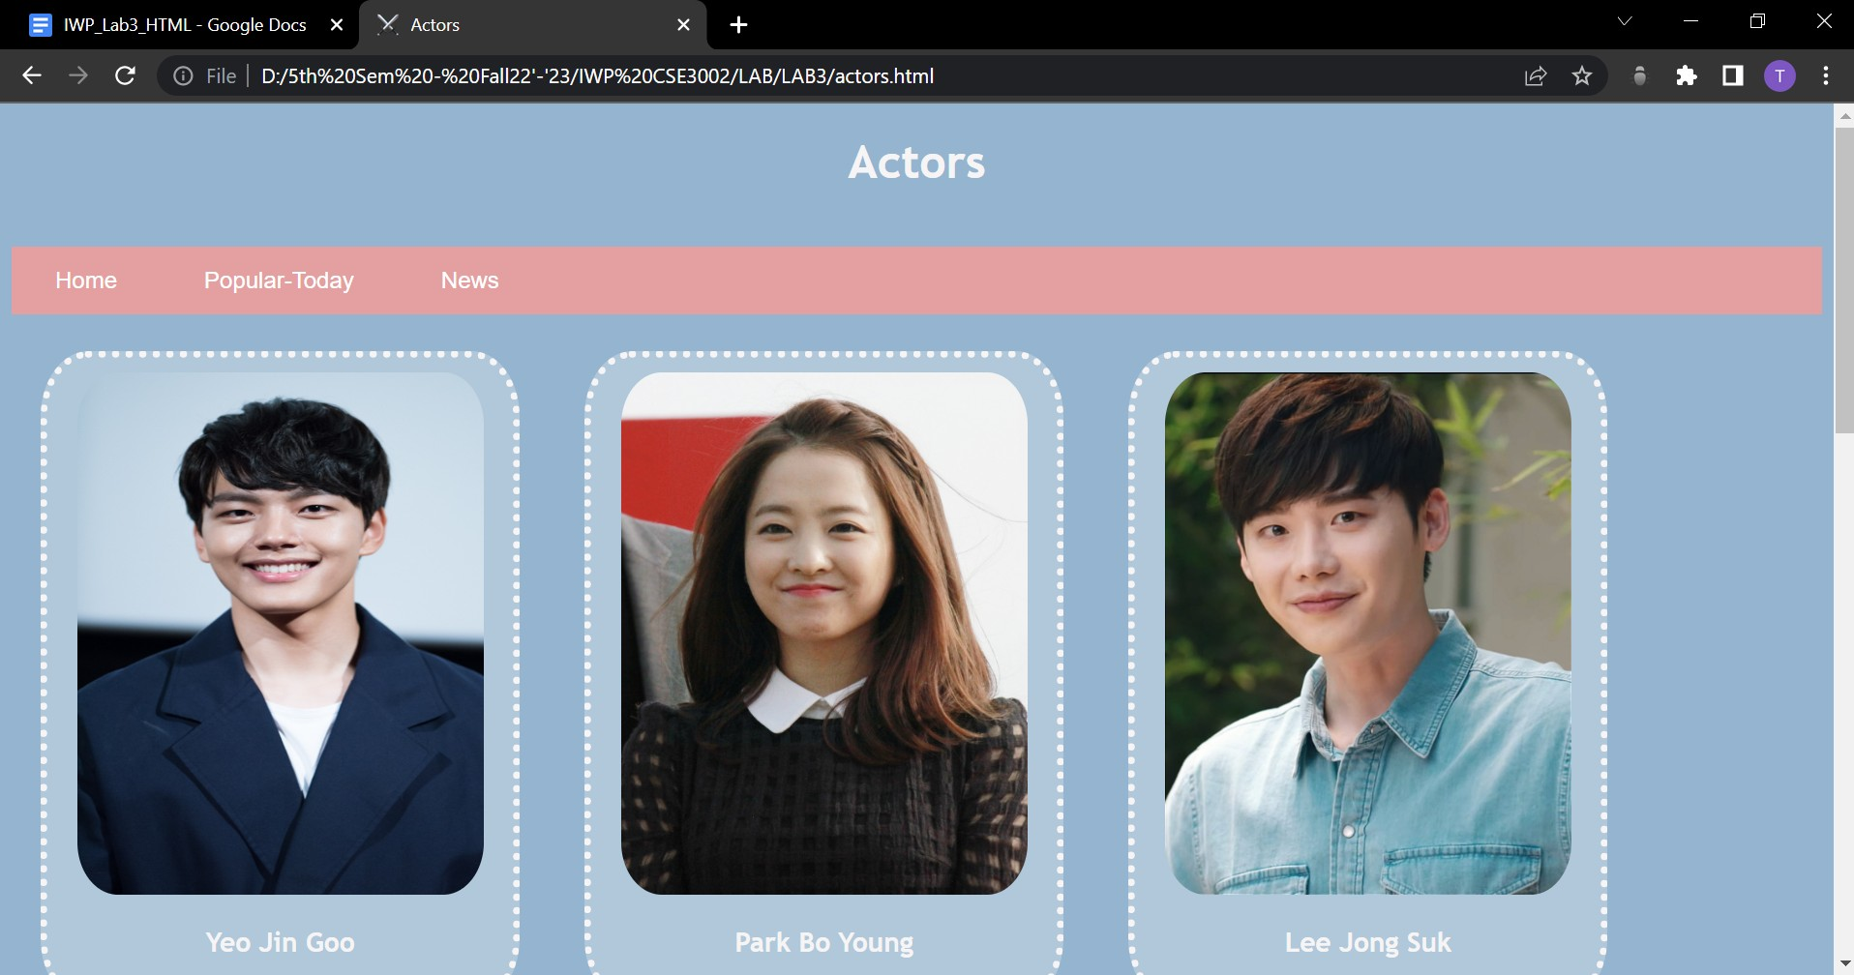***actors.html***

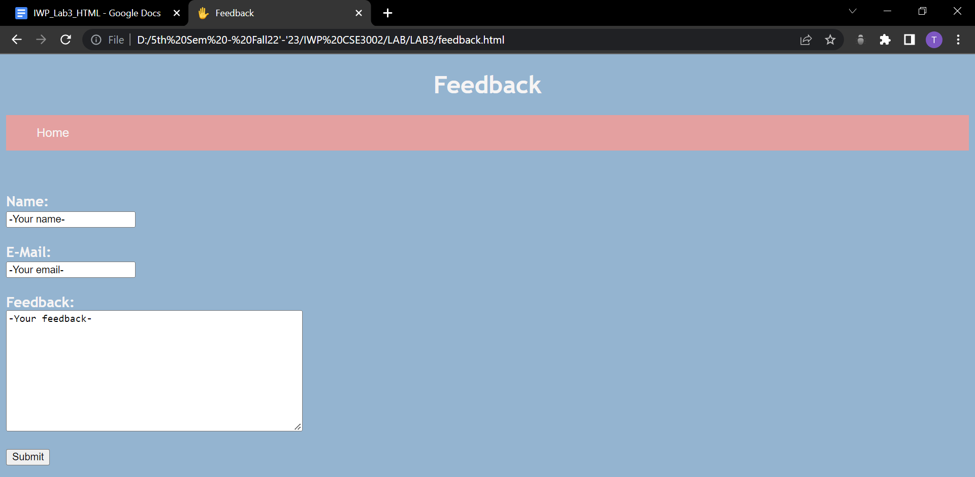

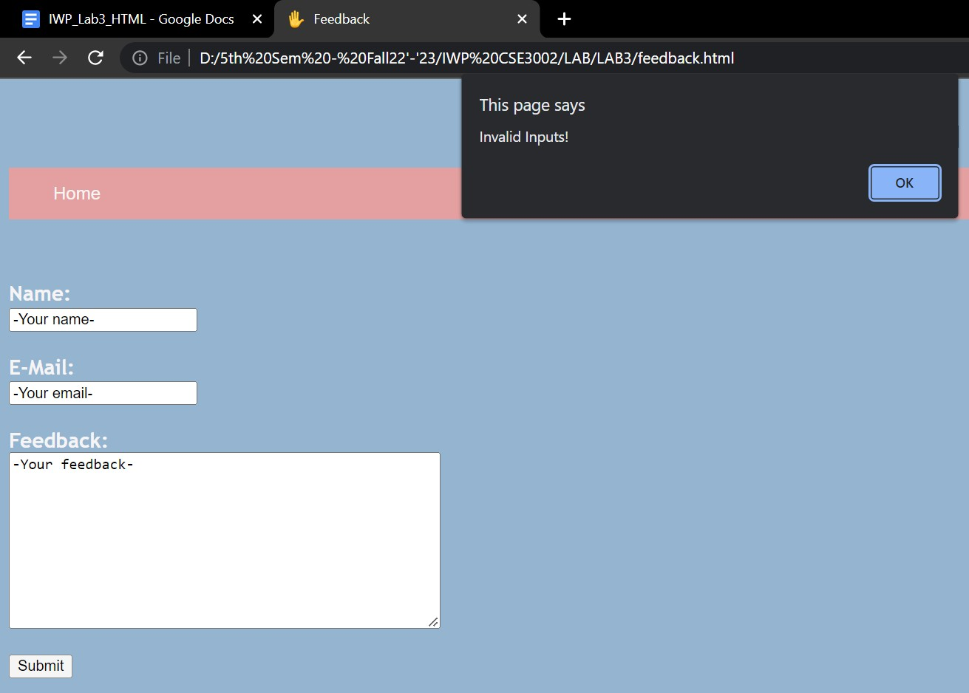

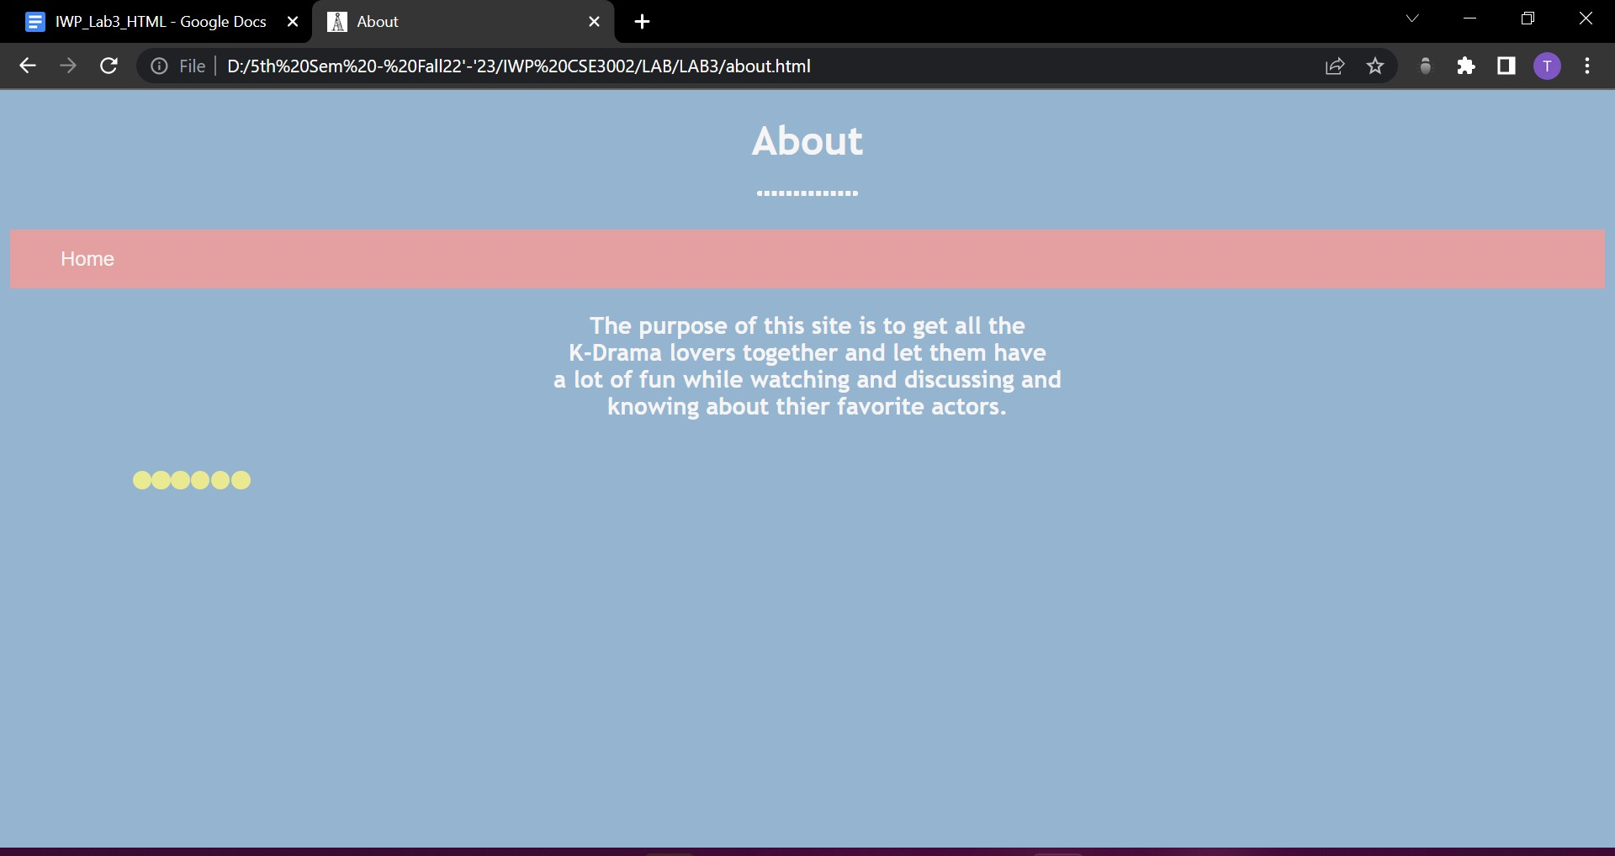

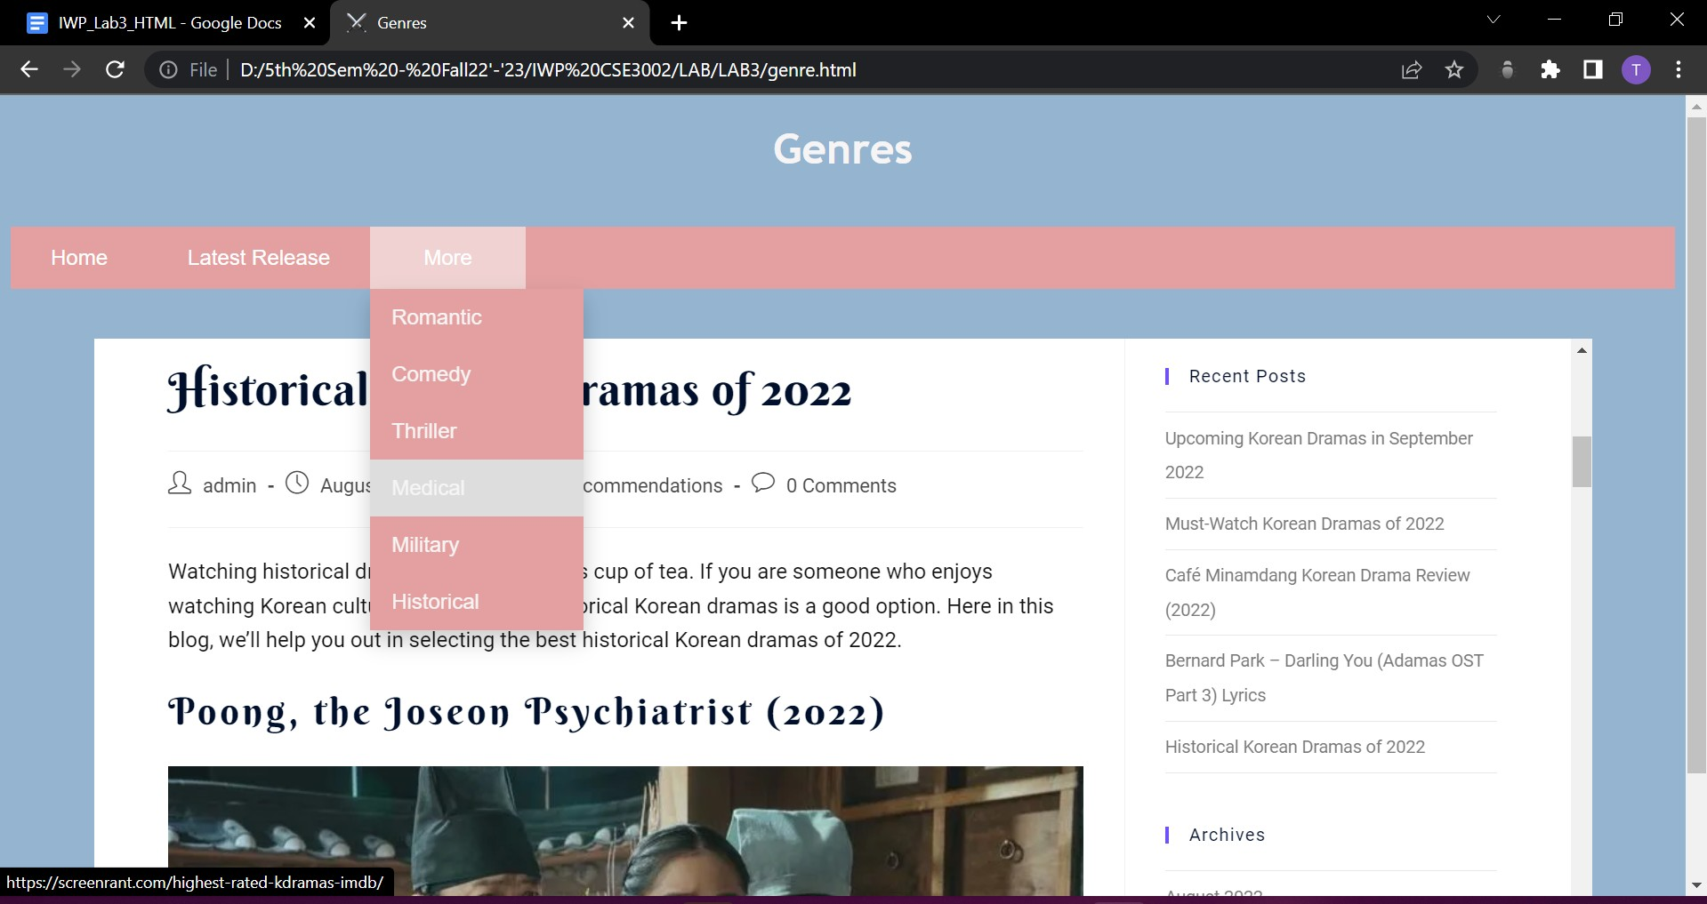***genre.html***

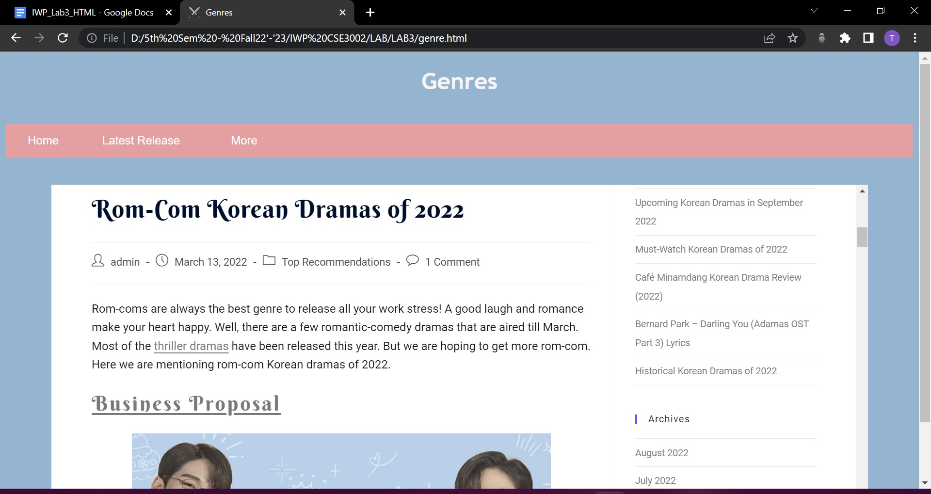

RESULT:

We learned how to make a simple website using HTML, CSS and inline JS.

***Date : 22-08-2022***

## Experiment #4

***AIM:*** To make a simple website using HTMLand JavaScript.

*<!--*

1. *Write a JavaScript program to calculate multiplication and division of two numbers. Get inputs from user.*
2. *Write a JavaScript program that accept two integers and display the larger*
3. *Write a JavaScript conditional statement to find the sign of a product of three numbers. Display an alert box with the specified sign. Sample numbers : 3, -7, 2*
4. *Write a JavaScript function to check whether an `input` is an array or not.*
5. *Write a simple JavaScript program to join all elements of the following array into a string.*
6. *Write a JavaScript program to sort the items of an array.*
7. *Write a JavaScript for loop that will iterate from 0 to 15. For each iteration, it will check if the current number is odd or even, and display a message to the screen.*
8. *Write a JavaScript conditional statement to find the largest of five numbers. Display an alert box to show the result.*
9. *Write a JS code to print numbers from 1 to 10*
10. *Write a JS code to print Even numbers in given array-->*

***PROCEDURE:***

* 1. Open Notepad.
  2. Type the code.
  3. Save the notepad file as ***filename.html*** or ***filename.js*** .
  4. Open the file on any browser available.

CODE:

***javas.js***

function one() {

var a = num_a.value; var b = num_b.value;

document.write("1st number " + a + "<br>");

document.write("2nd number " + b + "<br>");

var mul = a * b; var div = a / b;

document.write("Multiply \xa0\xa0\xa0\xa0\xa0\xa0\xa0 Divide"); document.write("<br>");

document.write(mul + "\xa0\xa0\xa0\xa0\xa0\xa0\xa0\xa0\xa0\xa0\xa0\xa0\xa0\xa0\xa0\xa0\xa0\xa0" + div); document.write("<br>");

}

function two() {

var a = num_a.value; var b = num_b.value; if (a > b) {

alert(a + " is greater than " + b);

} else {

alert(b + " is greater than " + a);

}

}

function three() {

var a = num_a.value; var b = num_b.value; var c = num_c.value;

if ((a < 0 && b >= 0 && c >= 0) || (a >= 0 && b < 0 && c >= 0) || (a >= 0 && b >= 0 && c < 0) || (a < 0 && b < 0 && c < 0)) {

alert("Sign of the product of 3 numbers is negative.");

} else {

alert("Sign of the product of 3 numbers is positive.");

}

}

function four() {

var d = prompt("Enter an array: "); d = String(d);

n = d.length;

if (d[0] == "[" && d[n - 1] == "]") {

alert(d + " is an array.");

} else {

alert(d + " is not an array.");

}

}

function five() {

var d = ["Tanvi", "is", "a", "good", "girl", "."]; let e = d.join(" ");

alert(e);

}

function six() {

var d = [1, 2, 6, 20, -21, 61, 7, 10, 22, -1];

alert("Before sort " + d); d.sort();

alert("After sort " + d);

}

function seven() {

for (var j = 0; j <= 15; j++) { if (j % 2 == 0) {

alert(j + " is even.");

} else {

alert(j + " is odd.\n");

}

}

}

function eight() {

var a = num_a.value; var b = num_b.value; var c = num_c.value; var d1 = num_d1.value;

var e1 = num_e1.value;

if (a > b && a > c && a > d1 && a > e1) { alert(a + " is largest");

} else {

if (b > c && b > d1 && b > e1) { alert(b + " is largest");

} else {

if (c > d1 && c > e1) { alert(c + " is largest");

} else {

if (d1 > e1) {

alert(d1 + " is largest");

} else {

alert(e1 + " is largest");

}

}

}

}

}

function nine() { var n = 10;

for (var l = 1; l <= n; l++) { document.write(l + "</br>");

}

}

function ten() {

var d = ["Tanvi", "is", "a", "good", "girl", "."]; var n = d.length;

for (var l = 0; l < n; l++) { alert(d[l]);

}

}

**lab4.html**

<!DOCTYPE html>

<html lang="en" dir="ltr">

<head>

<meta charset="utf-8">

<title>Lab4</title>

<script type="text/javascript" src="javas.js"></script>

</head>

<body>

<form name="form1" action="lab4.html" method="get">

<label for="num_a" form="form1">Number 1:</label>

<input type="number" id="num_a" name="num_a"><br><br>

<label for="num_b" form="form1">Number 2:</label>

<input type="number" id="num_b" name="num_b"><br><br>

<label for="num_c" form="form1">Number 3:</label>

<input type="number" id="num_c" name="num_c"><br><br>

<label for="num_d1" form="form1">Number 4:</label>

<input type="number" id="num_d1" name="num_d1"><br><br>

<label for="num_e1" form="form1">Number 5:</label>

<input type="number" id="num_e1" name="num_e1"><br><br>

<button name="button1" id="button1" onclick="one()">Submit1

<button name="button2" id="button2" onclick="two()">Submit2

<button name="button3" id="button3" onclick="three()">Submit3

<button name="button4" id="button4" onclick="four()">Submit4

<button name="button5" id="button5" onclick="five()">Submit5

<button name="button6" id="button6" onclick="six()">Submit6

<button name="button7" id="button7" onclick="seven()">Submit7

<button name="button8" id="button8" onclick="eight()">Submit8

<button name="button9" id="button9" onclick="nine()">Submit9

<button name="button10" id="button10" onclick="ten()">Submit10

</form>

</body>

</html>

OUTPUT:

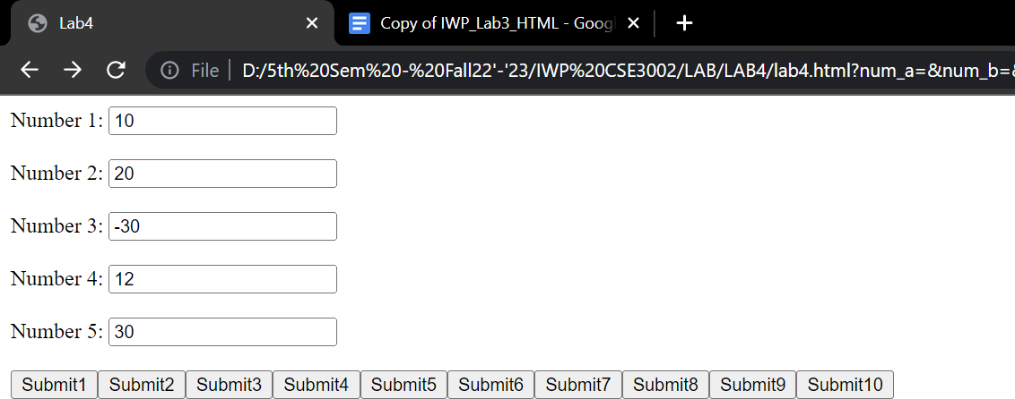

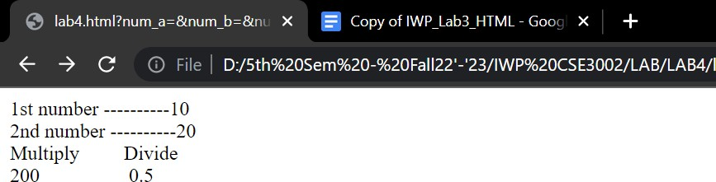***1.***

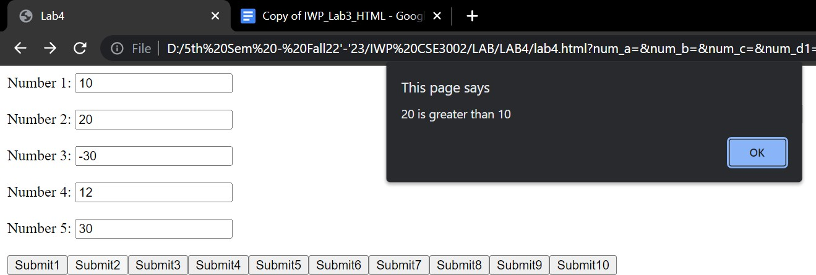***2.***

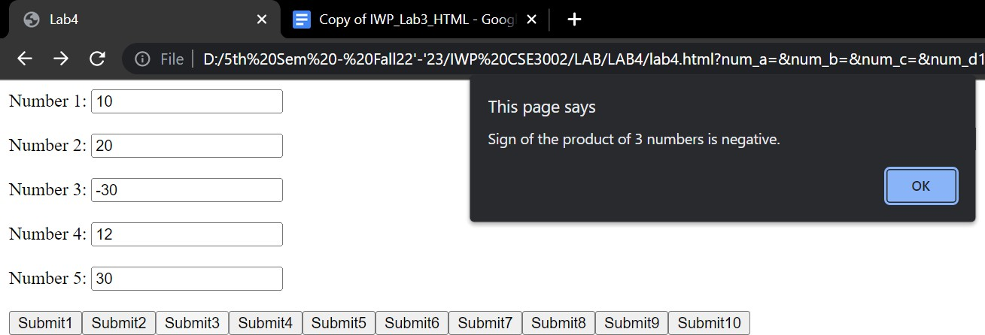***3.***

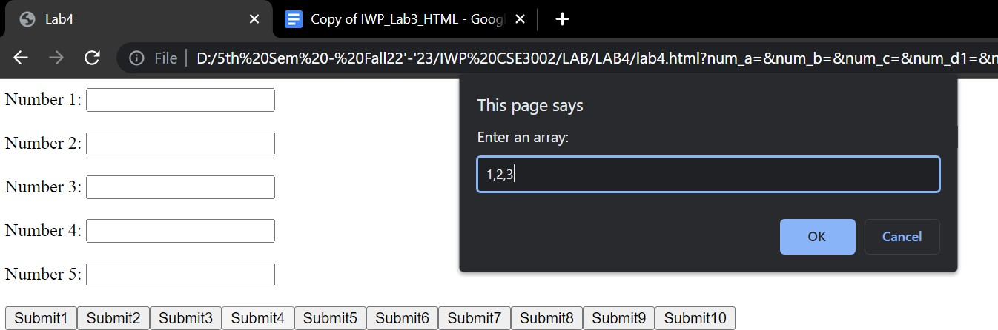***4.***

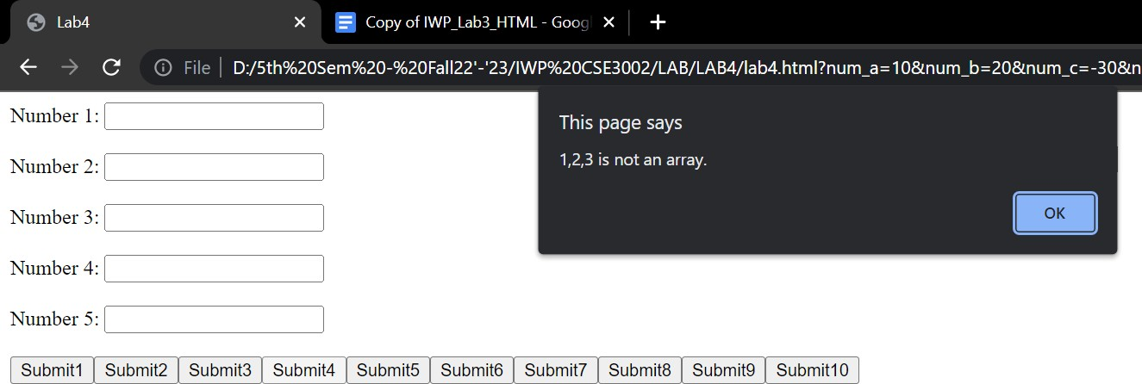

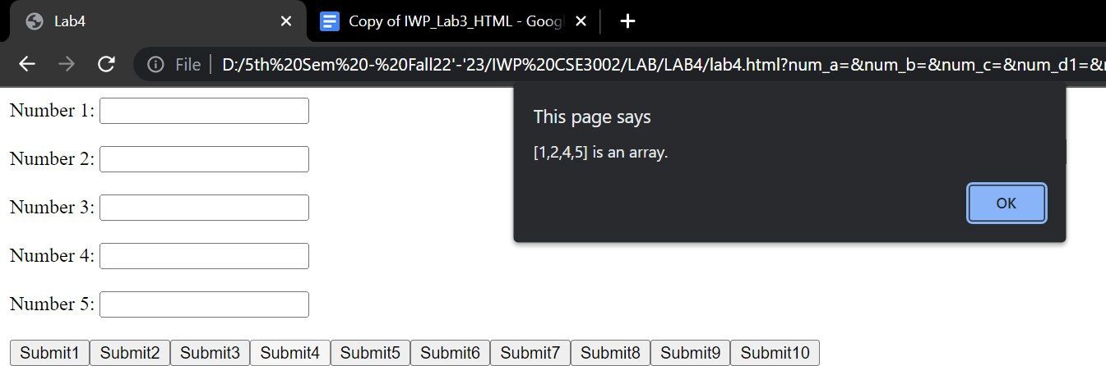

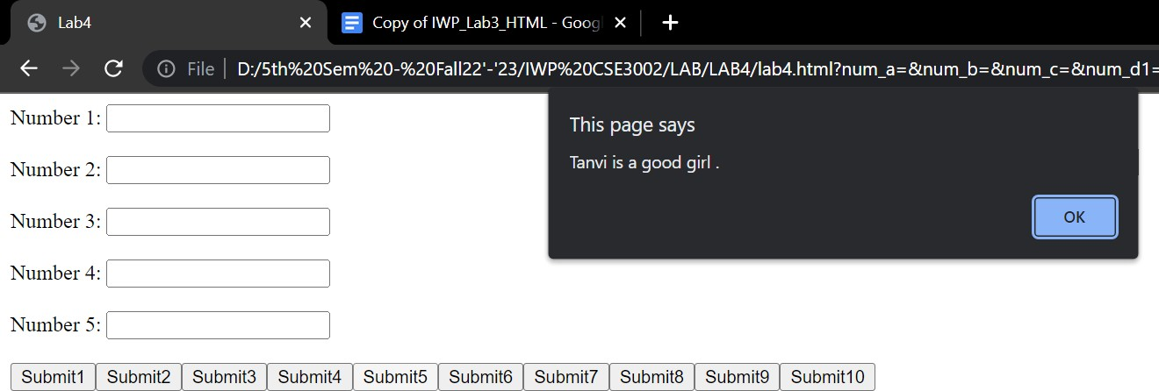***5.***

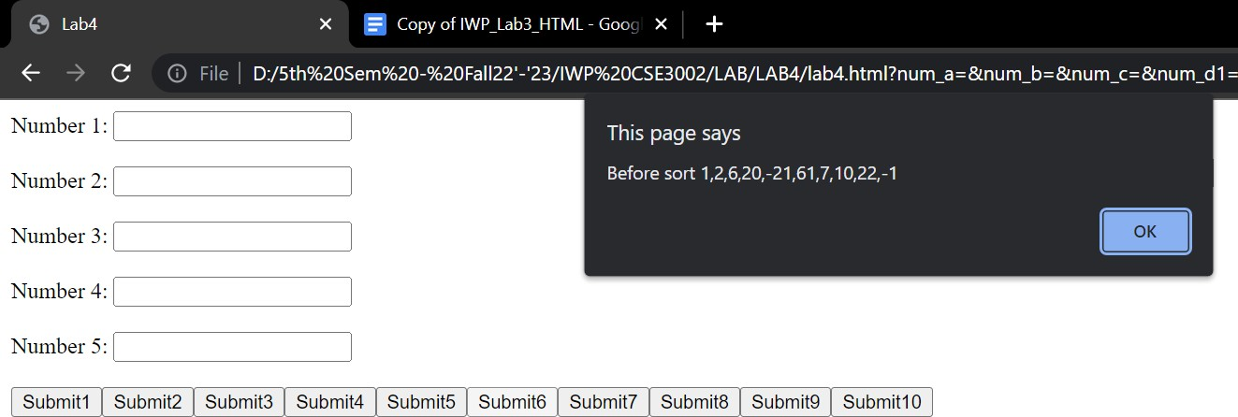***6.***

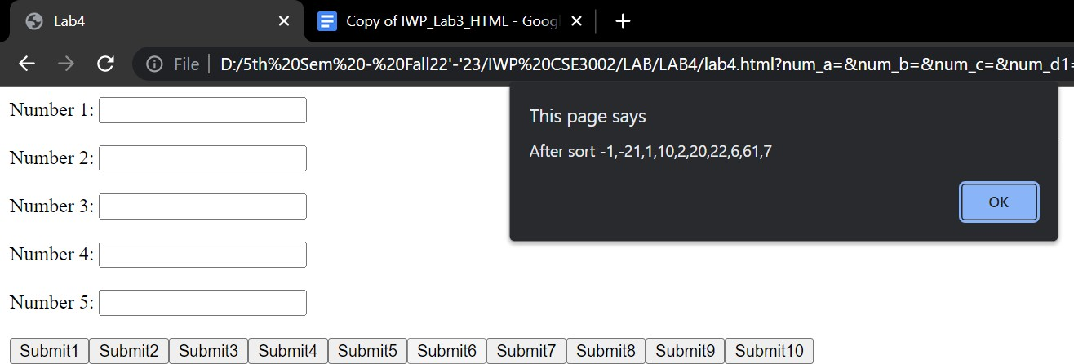

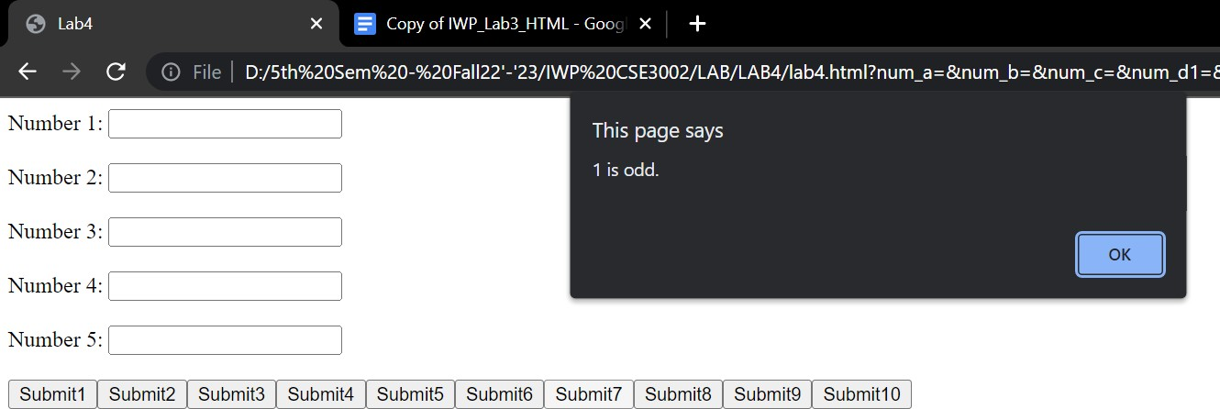***7.***

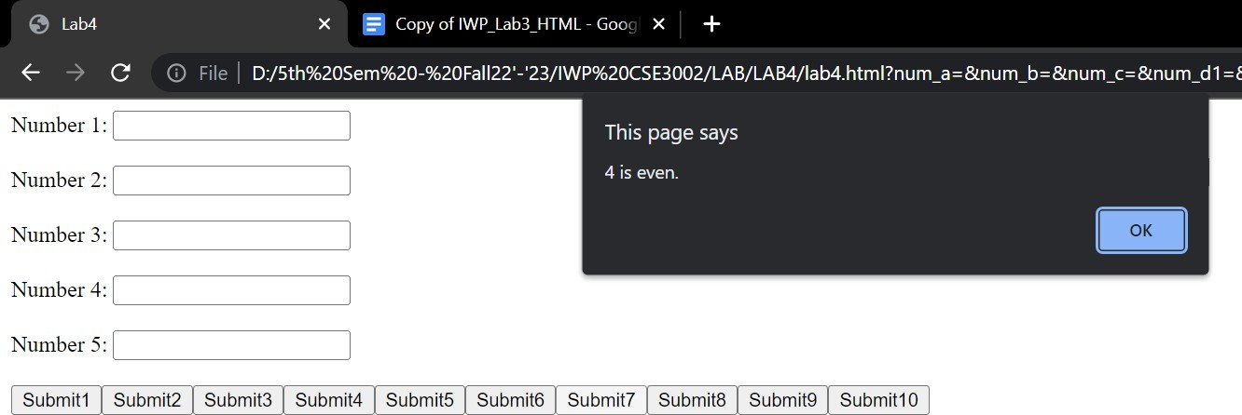

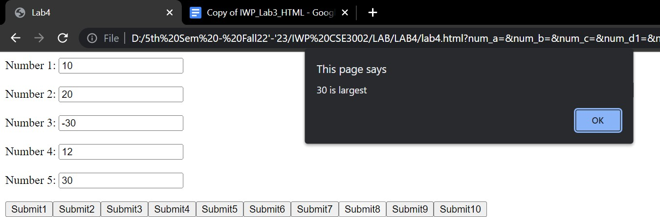***8.***

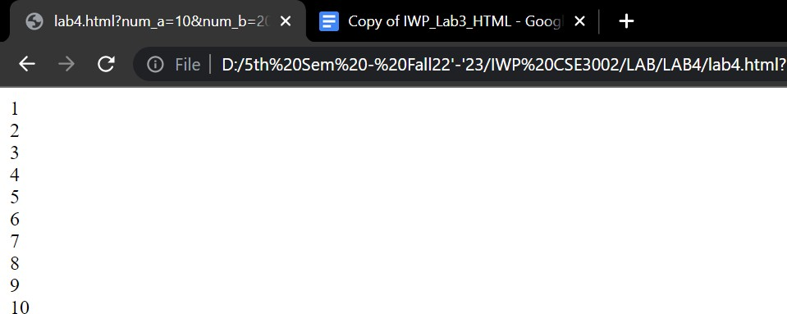***9.***

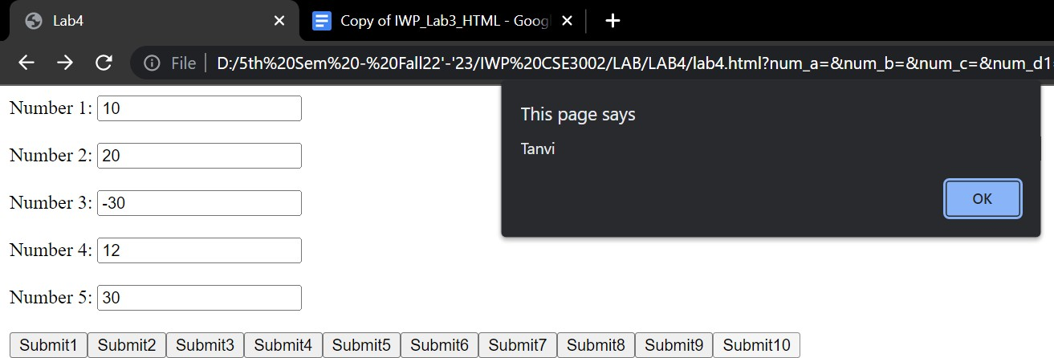***10.***

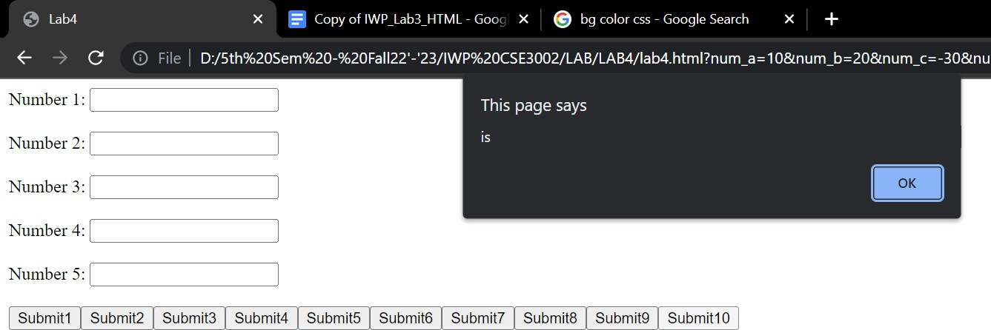

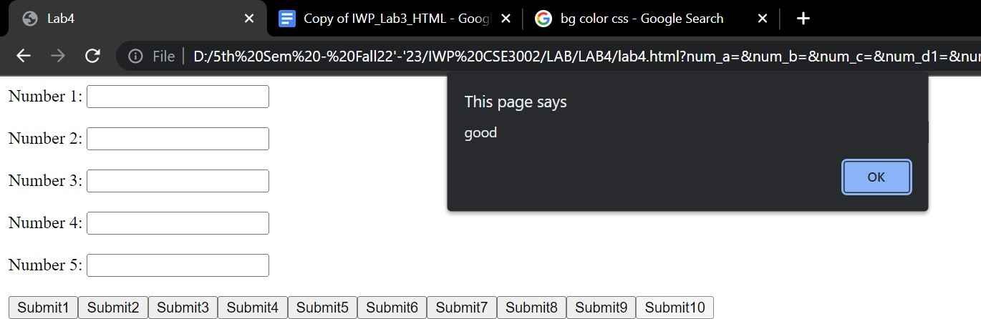

RESULT:

We learned how to make a simple website using HTML and JS.

## LAB 5

<!-- **QUESTIONS**

1. Make a simple web page that contains an h2 with the word “Hello” a text input box, and a button. When the user types a word or phrase into the input box and presses the button, replace the old h2 with the word entered. Using animation, make the word spin.
2. Make a simple web page that contains a button and a paragraph with the id of count Whenever this button is pressed increment the count by 1 and update the paragraph text.Also update the font size so that as the number gets larger, so does the font.
3. Create an html page with two text input boxes and four buttons. The buttons should be labeled

+, -, *, and /. When one of these buttons is pressed you should get the value from both text input boxes and add, subtract, multiply, or divide the numbers entered in the text input boxes. The result should be displayed below the buttons. Note In order to do math on the values you read from the text input boxes you will need to use Number.parseInt on the value. for example suppose you get a reference to input box 1 using

myIn1 = document.querySelector("#in1id");

then the statement value1 = Number.parseInt(myIn1.value)

converts the string from the text input box to an integer. In fact most of the time Javascript will do the conversion for you automatically except for addition.

1. Create a page that looks like the following image: The rest of the page must be created using javascript. You must use document.createElement and the appendChild functions
2. Write a JS code to count all letters in a word

-->

**Solution:-**

**1.**

<!DOCTYPE html>

<html lang="en">

<head>

<meta charset="utf-8">

<title>Lab5 Q1_20BCE1791</title>

</head>

<body>

<h2 id="heading">Hello</h2>

<input type="text" id="textbox" placeholder="Enter any text here"> <br><br>

<input type="button" name="Button" value="Submit" onclick="Animation()"> <br><br>

<script>

function Animation() {

var a = document.getElementById("heading"); var word = document.getElementById("textbox"); a.innerHTML = word.value;

a.transfrom();

}

</script>

</body>

</html>

**2.**

<!DOCTYPE html>

<html lang="en">

<head>

<meta charset="utf-8">

<title>Lab5_Q2</title>

</head>

<body>

<p id="input">

Hola Amigos! Como Estas ? Muy bien.

</p>

<button value="Submit" onclick="countCharacters()" id="submit">Submit</button>

<script type="text/javascript">

var a = document.getElementById("input").value;

function countCharacters(a) { var count = 0;

for (var i = 0; i < a.length(); i++) { if (a.charAt(i) != " ") count += 1;

}

}

alert("The number of characters in the given paragraph is:" + count);

</script>

</body>

</html>

**5.**

<html>

<body>

<script type="text/javascript"> var str = "Letter Count";

var regex = /[^a-z]/gi; alert(str.replace(/[^a-z]/gi, "").length);

</script>

</body>

</html>

**4.**

￼

<html>

<body>

<script>

const press = document.createElement("button"); press.innerHTML = "click here"; document.body.appendChild(press);

</script>

<h1> I am an H1</h1>

<p> This is a paragraph followed by a list </p>

<ol type='I'>

<li>This is first</li>

<li>This is second</li>

</ol>

</body>

</html>

￼

**LAB - 6**

**JavaScript**

1. Write a JavaScript to
   1. Create a dynamic table with two rows and two columns
   2. Change the color of the Button from red to green color on Mouse Over. (iii)Change the color of the Textbox from green to yellow color on Focus and display a

greeting message on Change

**Note:** Both button and textbox should be created using CreateElement

PROGRAM :

<!DOCTYPE html>

<html>

<head>

<meta charset="utf-8">

<meta name="viewport" content="width=device-width">

<title>q1</title>

</head>

<body id="bd">

<table id="1791">

</table>

</body>

</html>

**JS:**

table = document.createElement('table')

thead = document.createElement('thead') tbody = document.createElement('tbody') table.border="1" table.appendChild(thead) table.appendChild(tbody) document.getElementById('1795').appendChild(table) row_1 = document.createElement('tr')

heading_1 = document.createElement('th') heading_1.innerHTML = "ID" heading_2 = document.createElement('th')

heading_2.innerHTML = "Name"

heading_3 = document.createElement('th') heading_3.innerHTML = "City" row_1.appendChild(heading_1) row_1.appendChild(heading_2) row_1.appendChild(heading_3) thead.appendChild(row_1)

row_2 = document.createElement('tr'); row_2_data_1 = document.createElement('td') row_2_data_1.innerHTML = "1."

row_2_data_2 = document.createElement('td') row_2_data_2.innerHTML = "Aayushi" row_2_data_3 = document.createElement('td') row_2_data_3.innerHTML = "Begusarai" row_2.appendChild(row_2_data_1) row_2.appendChild(row_2_data_2)

row_2.appendChild(row_2_data_3) tbody.appendChild(row_2);

row_3 = document.createElement('tr') row_3_data_1 = document.createElement('td') row_3_data_1.innerHTML = "2."

row_3_data_2 = document.createElement('td') row_3_data_2.innerHTML = "Siddharth" row_3_data_3 = document.createElement('td') row_3_data_3.innerHTML = "Begusarai" row_3.appendChild(row_3_data_1) row_3.appendChild(row_3_data_2)

row_3.appendChild(row_3_data_3) tbody.appendChild(row_3)

var button = document.createElement("button") button.innerHTML = "Click" button.style.backgroundColor="red"

button.addEventListener ("mouseover", function() { button.style.backgroundColor="green"}) button.addEventListener ("mouseout", function() { button.style.backgroundColor="red"}) document.body.appendChild(button) br = document.createElement("br") document.body.appendChild(br) var x = document.createElement("INPUT") x.setAttribute("type", "text")

x.style.backgroundColor="green"

x.onclick = function(){ x.value = "Welcome!" x.style.backgroundColor = "yellow" x.focus()}

x.onmouseout = function(){x.value="" x.style.backgroundColor="green" x.blur()} document.body.appendChild(x)

1. Devise a program to withdraw the amount from the bank account. While withdraw, the program should check the amount in the account. If the amount in the account is greater thanthe amount entered then raise the exception “Amount withdraw failure” else withdraw the amount.

Program :

html

<!DOCTYPE html>

<html>

<head>

<meta charset="utf-8">

<meta name="viewport" content="width=device-width">

<title>Q2</title>

</head>

<body>

<button onclick="withdraw()">Withdraw</button>

</body>

</html>

**js**

function withdraw(){try

{

var a = prompt("Enter withdrawal amount : ")var b = 5000

if(a<b)

{

var bal=b-a

document.write("Total amount in balance: "+bal)

}

else

{

throw new Error('Amount withdraw failure')

}

}

catch(e)

{

document.write(e.message)

}

}

Output

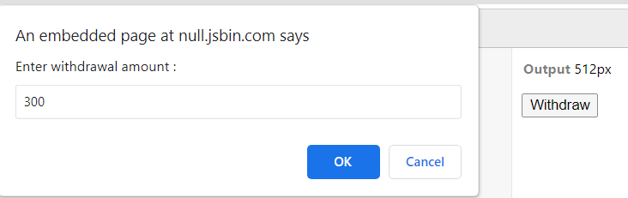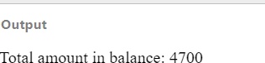

1. Design the **below form** and do the following
   1. Set the timer to display the current time
   2. Print the form content
   3. Use getElemnetsByName to display Gender, Country and Preferences(iv)Validate
      1. All Mandatory Fields (represented by *)
      2. Name should not exceed 15 characters
      3. Address – to be specified in Text Area
      4. Zip code should be numeric and validated the maximum digits
      5. Phone numbers should be numeric and validated the maximum digits 10
      6. e-mail syntax should be validated
      7. Password should contain a number, character & a special character and lengthshould not exceed 15 and recede 8
      8. PAN card number – Textbox (validate such that the PAN number is 10 digits andfollows the pattern)

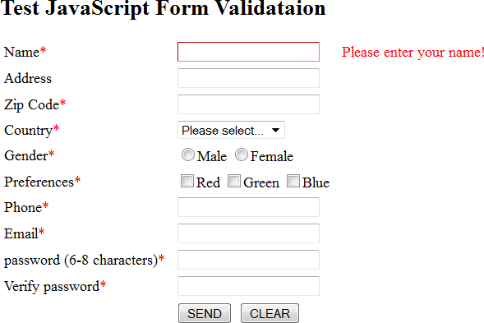

Pan No:

Time:11:30:55

**Program:**

<!DOCTYPE html>

<html lang="en">

<head>

<meta charset="UTF-8">

<meta http-equiv="X-UA-Compatible" content="IE=edge">

<meta name="viewport" content="width=device-width, initial-scale=1.0">

<title>Lab6Q3_20BCe1667</title>

<style>

.required { color: red;

}

.errorMsg { color: red;

}

.errorBox {

border: 2px solid red;

}

table { border: 0;

}

td {

margin: 0; padding: 3px 10px;

}

.head { display: flex;

justify-content: space-between; width: 500px;

}

.bo {

border: 1px solid black; width: fit-content;

}

</style>

</head>

<body>

<div class="bo">

<div class="head">

<h2>Test Javascript Form Validation</h2>

<p style="border: 1px solid black;" id="date">123456</p>

</div>

<form id="formTest" method="get" action="processData">

<table>

<tr>

<td><label for="txtName">Name<span class="required">*</span></label></td>

<td><input type="text" id="txtName" name="name"></td>

<td id="elmNameError" class="errorMsg">&nbsp;</td>

</tr>

<tr>

<td><label for="txtAddress">Address</label></td>

<td><input type="text" id="txtAddress" name="address"></td>

<td id="elmAddressError" class="errorMsg">&nbsp;</td>

</tr>

<tr>

<td><label for="txtZipcode">Zip Code<span class="required">*</span></label></td>

<td><input type="text" id="txtZipcode" name="zipcode"></td>

<td id="elmZipcodeError" class="errorMsg">&nbsp;</td>

</tr>

<tr>

<td>Country<span class="required">*</span></td>

<td><select id="selCountry" name="country">

<option value="" selected>Please select...</option>

<option value="AA">India</option>

<option value="BB">Romania</option>

<option value="CC">Russia</option>

</select></td>

<td id="elmCountryError" class="errorMsg">&nbsp;</td>

</tr>

<tr>

<td>Gender<span class="required">*</span></td>

<td><label><input type="radio" name="gender" value="m">Male</label>

<label><input type="radio" name="gender" value="f">Female</label>

</td>

<td id="elmGenderError" class="errorMsg">&nbsp;</td>

</tr>

<tr>

<td>Preferences<span class="required">*</span></td>

<td><label><input type="checkbox" name="color" value="r">Red</label>

<label><input type="checkbox" name="color" value="g">Green</label>

<label><input type="checkbox" name="color" value="b">Blue</label>

</td>

<td id="elmColorError" class="errorMsg">&nbsp;</td>

</tr>

<tr>

<td><label for="txtPhone">Phone<span class="required">*</span></label></td>

<td><input type="text" id="txtPhone" name="phone"></td>

<td id="elmPhoneError" class="errorMsg">&nbsp;</td>

</tr>

<tr>

<td><label for="txtEmail">Email<span class="required">*</span></label></td>

<td><input type="text" id="txtEmail" name="email"></td>

<td id="elmEmailError" class="errorMsg">&nbsp;</td>

</tr>

<tr>

<td><label for="txtPassword">Password (6-8 characters)<span class="required">*</span></label></td>

<td><input type="password" id="txtPassword" name="password"></td>

<td id="elmPasswordError" class="errorMsg">&nbsp;</td>

</tr>

<tr>

<td><label for="txtPWVerified">Verify Password<span class="required">*</span></label></td>

<td><input type="password" id="txtPWVerified" name="pwVerified"></td>

<td id="elmPWVerifiedError" class="errorMsg">&nbsp;</td>

</tr>

<tr>

<td>&nbsp;</td>

<td><input type="submit" value="SEND" id="btnSubmit">&nbsp;

<input type="reset" value="CLEAR" id="btnReset">

</td>

<td>&nbsp;</td>

</tr>

</table>

</form>

</div>

<script type="text/javascript"> window.onload = init;

function init() {

document.getElementById("formTest").onsubmit = validateForm; document.getElementById("btnReset").onclick = clearForm; document.getElementById("txtName").focus();

var d = document.getElementById("date") setInterval(() => { var t = new Date()

d.innerHTML = `Time: ${t.getHours()}:${t.getMinutes()}:${t.getSeconds()}`

}, 1000);

}

function validateForm(theForm) { with(theForm) {

return (isNotEmpty(txtName, "Please enter your name!", elmNameError) && isNumeric(txtZipcode, "Please enter a 6-digit zip code!",

elmZipcodeError) &&

isLengthMinMax(txtZipcode, 6, 6, "Please enter a 6-digit zip code!", elmZipcodeError) && isSelected(selCountry, "Please make a selection!", elmCountryError) &&

isChecked("gender", "Please check a gender!", elmGenderError) && isChecked("color", "Please check a color!", elmColorError) && isNumeric(txtPhone, "Please enter a valid phone number!",

elmPhoneError) &&

isValidEmail(txtEmail, "Enter a valid email!", elmEmailError) && isValidPassword(txtPassword, "Password shall be 6-8 characters!", elmPasswordError) && verifyPassword(txtPassword, txtPWVerified, "Different from new

password!",

);

}

}

elmPWVerifiedError)

function postValidate(isValid, errMsg, errElm, inputElm) { if (!isValid) {

if (errElm !== undefined && errElm !== null && errMsg !== undefined && errMsg !== null) { errElm.innerHTML = errMsg;

}

if (inputElm !== undefined && inputElm !== null) { inputElm.classList.add("errorBox"); // Add class for styling inputElm.focus();

}

} else {

if (errElm !== undefined && errElm !== null) {

errElm.innerHTML = "";

}

if (inputElm !== undefined && inputElm !== null) { inputElm.classList.remove("errorBox");

}

}

}

function isNotEmpty(inputElm, errMsg, errElm) { var isValid = (inputElm.value.trim() !== ""); postValidate(isValid, errMsg, errElm, inputElm); return isValid;

}

function isNumeric(inputElm, errMsg, errElm) {

var isValid = (inputElm.value.trim().match(/^\d+$/) !== null); postValidate(isValid, errMsg, errElm, inputElm);

return isValid;

}

function isAlphabetic(inputElm, errMsg, errElm) {

var isValid = (inputElm.value.trim().match(/^[a-zA-Z]+$/) !== null); postValidate(isValid, errMsg, errElm, inputElm);

return isValid;

}

function isAlphanumeric(inputElm, errMsg, errElm) {

var isValid = (inputElm.value.trim().match(/^[0-9a-zA-Z]+$/) !== null); postValidate(isValid, errMsg, errElm, inputElm);

return isValid;

}

function isLengthMinMax(inputElm, minLength, maxLength, errMsg, errElm) { var inputValue = inputElm.value.trim();

var isValid = (inputValue.length >= minLength) && (inputValue.length <= maxLength); postValidate(isValid, errMsg, errElm, inputElm);

return isValid;

}

function isValidEmail(inputElm, errMsg, errElm) { var isValid = (inputElm.value.trim().match(

/^\w+([\.-]?\w+)@\w+([\.-]?\w+)(\.\w{2,3})+$/) !== null); postValidate(isValid, errMsg, errElm, inputElm);

return isValid;

}

function isSelected(selectElm, errMsg, errElm) { var isValid = (selectElm.value !== ""); postValidate(isValid, errMsg, errElm, selectElm); return isValid;

}

function isChecked(inputName, errMsg, errElm) {

var elms = document.getElementsByName(inputName);

var isChecked = false;

for (var i = 0; i < elms.length; ++i) { if (elms[i].checked) {

isChecked = true; break;

}

}

postValidate(isChecked, errMsg, errElm, null); return isChecked;

}

function isValidPassword(inputElm, errMsg, errElm) {

var isValid = (inputElm.value.trim().match(/^\w{6,8}$/) !== null); postValidate(isValid, errMsg, errElm, inputElm);

return isValid;

}

function verifyPassword(pwElm, pwVerifiedElm, errMsg, errElm) { var isTheSame = (pwElm.value === pwVerifiedElm.value); postValidate(isTheSame, errMsg, errElm, pwVerifiedElm); return isTheSame;

}

function clearForm() {

var elms = document.querySelectorAll('.errorBox'); for (var i = 0; i < elms.length; i++) { elms[i].classList.remove("errorBox");

}

elms = document.querySelectorAll('[id$="Error"]'); for (var i = 0; i < elms.length; i++) { elms[i].innerHTML = "";

}

document.getElementById("txtName").focus();

}

</script>

</body>

</html>

1. The following are the daily temperature recordings of DELHI (In Fahrenheit) 55,62,68,74,59,45,41,58,60,67,65,78,82,88,91,92,90,93,87,80,78,79,72,68,61,59

,55,65 Your JavaScript program should count and print the number of HOT days (HighTemperature: 85 or higher), the number of PLEASANT days (High temperature: 60-84)and the number of COLD days (High temperature<60) in the city. It should also displaythe category of each temperature in an HTML Table. Use JavaScript arrays.

html

<!DOCTYPE html>

<html>

<head>

<meta charset="utf-8">

<meta name="viewport" content="width=device-width">

<title>Q4</title>

</head>

<body>

</body>

</html>

**css**

th, td{

border: 1px solid black;

}

**js**

temp = [55,62,68,74,59,45,41,58,60,67,65,78,82,88,91,92,90,93,87,80,78,79,72,68,61,59,55,65]

table = document.createElement("table")tr = document.createElement("tr")

th1 = document.createElement("th") th1.innerHTML = "Temperature" tr.appendChild(th1)

th2 = document.createElement("th") th2.innerHTML = "Category" tr.appendChild(th2) table.appendChild(tr)

for(var t in temp){ if(temp[t]>=85) cat = "HOT"

else if(temp[t]>=60) cat = "PLEASANT"else cat = "COLD"

tr = document.createElement("tr") td1 = document.createElement("td") tr.appendChild(td1)

td1.innerHTML = temp[t]

td2 = document.createElement("td") td2.innerHTML = cat tr.appendChild(td2) table.appendChild(tr)

}

document.body.appendChild(table)

Output

1. 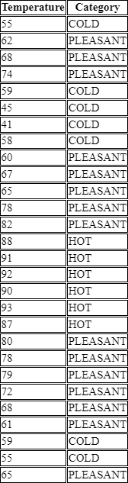Use JavaScript to develop the web page as given in Fig.1 to calculate the Body Mass Index (BMI) and display the adult’s status through appropriate popup boxes. For example, the BMI rate of the men is 21, and then prints the status through a popup box as “Ideal Range” by triggering the event on a “Calculate” button.

Note: Refer Table.1 to get the BMI criteria information.

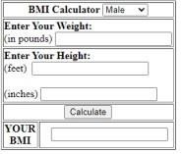BMI=703*weight/Height2

Fig.1. BMI

CalculatorTable.1 BMI Criteria

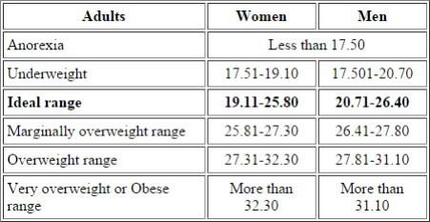

Program :

<!DOCTYPE html>

<html lang="en">

<head>

<meta charset="utf-8">

<title>BMI_Calculator_20BCE1791</title>

<style> table, td {

border: 1px solid black;

}

button {

margin: 0 100px;

}

#bmi {

margin: 0 20px;

}

</style>

</head>

<script type="text/javascript"> function calc() {

gn = document.getElementById('gender').value

wt = Number.parseFloat(document.getElementById('pn').value)

ht = Number.parseFloat(document.getElementById('ft').value * 12) + Number.parseFloat(document.getElementById('in').value)

bmi = 703 * wt / (ht * ht) document.getElementById('bmi').value = bmi if (bmi < 17.50) status = "Anorexia"

else if ((bmi <= 19.10 && gn === "f") || (bmi <= 20.70 && gn === "m")) status = "Underweight" else if ((bmi <= 25.80 && gn === "f") || (bmi <= 26.40 && gn === "m")) status = "Ideal"

else if ((bmi <= 27.30 && gn === "f") || (bmi <= 27.80 && gn === "m")) status = "Marginally Overweight" else if ((bmi <= 32.30 && gn === "f") || (bmi <= 31.10 && gn === "m")) status = "Overweight"

else status = "Obese"

alert("BMI: " + bmi + "\nStatus: " + status)

}

</script>

<body>

<table>

<tr>

<td colspan="2">

<b>BMI Calculator</b>

<select id="gender">

<option value="m">Male</option>

<option value="f">Female</option>

</select>

</td>

</tr>

<tr>

<td colspan="2">

<b>Enter Your Weight:</b><br> (in pounds)

<input type="number" id="pn">

</td>

</tr>

<tr>

<td colspan="2">

<b>Enter Your Height:</b><br> (feet)

<input type="number" id="ft"><br><br> (inches)

<input type="number" id="in">

</td>

</tr>

<tr>

<td colspan="2">

<button onclick="calc()" type="submit">Calculate</button>

</td>

</tr>

<tr>

<td>

YOUR <br> BMI

</td>

<td>

<input readonly type="text" id="bmi">

</td>

</tr>

</table>

</body>

</html>

OUTPUT :-

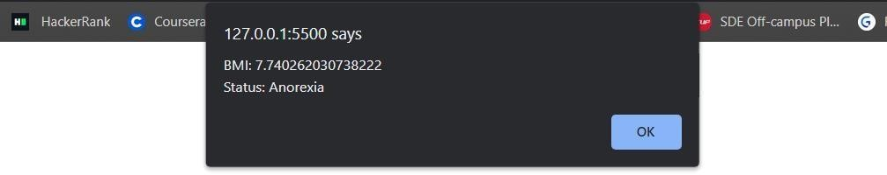

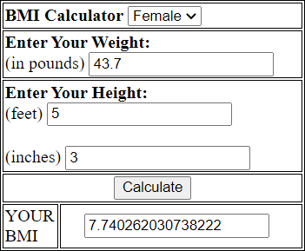

1. A small airline has just purchased a computer for its newly automated reservations system. Write a JavaScript program to assign seats on each flight (capacity: 10 seats). Your program should display the following:

* If the person types 1, assign a seat in the first-class section (seats 1–5).
* If the person types 2, assign a seat in the economy section (seats 6–10).
* When the first-class section is full, your program should ask the person if it is acceptable to be placed in the economy section (and vice versa)

Allot the seats based on the above choices. Print a boarding pass indicating the person’sname, seat number and class

Use a one-dimensional array to represent the seating chart of the plane. Initialize all the elements of the array to 0 to indicate that all the seats are empty. As each seat is assigned, set thecorresponding elements of the array to 1 to indicate that the seat is booked.

Html

<!DOCTYPE html>

<html>

<head>

<meta charset="utf-8">

<meta name="viewport" content="width=device-width">

<title>JS Bin</title>

</head>

<body>

<button onclick="book()">Book Flight</button><br>

<span id="tk"></span>

</body>

</html>

**js**

var seats = [0,0,0,0,0,0,0,0,0,0]

var e = 0 var fc = 0

function book(){fl = 0

ch = prompt("Enter\n1 for First-Class section\n2 for Economy section")if(ch === ""){

alert("Incorrect Input")ch

= 0

}

else{

ch = Number.parseInt(ch)

}

if(fc+e==10){ alert("All seats full!!")ch = 0

}

if(ch==1 && fc<5){fl = 1 seats[fc] = 1;

fc++ s = fc

}

else if(ch==2 && e<5){fl = 1

seats[e+5] = 2 e++

s = e+5

}

else if(ch==1 && fc==5 && e<5){ console.log("fc: "+fc)

if (confirm("First-Class seats are full\nWould you like to go with Economy seats?") ==true){ fl = 1

seats[e+5] = 2

e++

s = e+5

}

else{

alert("Sorry for the inconvenience!")

}

}

else if(ch==2 && e==5 && fc<5){ console.log("e: "+e)

if (confirm("Economy seats are full\nWould you like to go with First-Class seats?") ==true){ fl = 1

seats[fc] = 1

fc++ s = fc

}

else{

alert("Sorry for the inconvenience!")

}

}

if(s>5 && s>0){cl = "Economy"

}

else{

cl = "First-Class"

}

if(fl == 1){

nm = prompt("Enter your name:")

disp = "Name: "+nm+"<br>Seat: "+s+"<br>Class: "+cl document.getElementById("tk").innerHTML = disp

}

}

**Output**

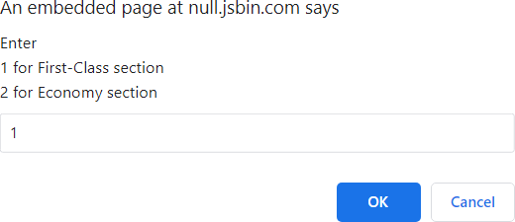

# LAB 7

### INPUT:

***JS-DOM:***

<!DOCTYPE html>

<html lang="en">

<head>

<meta charset="UTF-8">

<meta name="viewport" content="width=device-width, initialscale=1.0">

<title>TimesNow NewsPaper</title>

<style>

* {

box-sizing: border-box;

}

body, html {

font-family: 'Arial', Arial, monospace;

font-family: 'Times New Roman', Times, serif; background-color: #dfdfdf;

color: #2f2f2f; text-align: justify;

}

img {

width: 400;

height: 300;

margin: 20px 0;

}

.header { width: 100%; display: flex;

justify-content: space-between; alignitems: center;

}

h1 {

font-size: 3.5rem;

}

button {

padding: 10px 30px;

font-size: 1.2rem; font-weight:

700;

background-color: transparent; border: 2px solid #2f2f2f;

}

button:hover { color: #f9f7f1;

background-color: #2f2f2f;

}

.author {

text-align: center;

font-family: 'Times New Roman', Times, serif;

font-size: 1.2rem;

.author2 { display: none;

}

hr {

border: 1px solid #2f2f2f;

}

.content1 { display: flex;

}

.content2 { display: none;

}

.news-container { margin-top: 20px; padding: 0 30px;

flex: 1;

}

.left {

border-right: 1px solid #2f2f2f;

}

.news-header { font-size: 2rem;

line-height: 3rem;

}

.news-content {

font-family: 'Arial', Arial, monospace; line-height: 2rem;

}

</style>

</head>

<body>

<div class="header">

<button class="btn-back"> Back </button>

<h1>TimesNow News Paper</h1>

<button class="btn-next"> Next </button>

</div>

<hr>

<div class="author author1"> India 20-09-2021 by Rakesh K S

</div>

<div class="author author2"> India-2 20-09-2021 by Manya Gaur

</div>

<hr>

<div class="content1">

<div class="news-container left">

<h2 class="news-header">Japan braced for exceptional typhoon</h2>

<div class="news-content">Hundreds of thousands of people in Japan have been urged to evacuate their homes amid warnings of

"unprecedented"

risks from an approaching storm.

Typhoon Nanmadol is expected to make landfall on Kyushu island on Sunday.

Winds could reach 270km/h (168mph) and some areas could experience 500mm (20 inches) of rainfall in just 24 hours.

A "special alert" is in force for Kyushu, with warnings

of landslides and flooding. Train services and flights have been cancelled.

Kyushu is the southernmost of the four islands that make

up the main body of Japan and has a population of over 13 million

people.

This is the first special alert ever issued outside the

Okinawa Prefecture, which consists of the smaller, remote islands in

the East

China Sea,

the Japan Times reports. <br>

<img src="https://st.depositphotos.com/1186248/3276/i/950/depositphotos_32760371- stock-photo-breaking-news.jpg" alt="breaking news-1" width=500 height=500>

<br>

Once the typhoon makes landfall, it is expected to

turn north-east and move up through central Japan towards Tokyo.

It is also expected to maintain much of its strength even after making landfall.

An official from Japan's meteorological agency told reporters on Saturday:

"There are risks of unprecedented storms, high waves, storm surges, and record rainfall."

</div>

<div class="news-container right">

<h2 class="news-header">Toyota adds Renovo Motors to its Woven Planet R&D group</h2>

<div class="news-content"> Toyota adds Renovo Motors for building the future ahead.

<br> Toyota adds Renovo Motors to its Woven Planet R&D group <br> Alternatives,Technology,Emerging

Technologies,Autonomous,Future\n\nContinue reading Toyota adds Renovo Motors to

its Woven Planet R&D

group\n\nToyota adds Renovo Motors to its Woven Planet R&D group originally appeared

<br> Japanese automaker Toyota is revving up

acquisitions in mobility technology, adding Renovo Motors Inc., a Silicon Valley software developer, to its

Woven Planet team, which is working on automated driving.\nThe

addition,

announced Tuesday, follows…", <br>

</div>

</div>

</div>

<div class="content2">

<div class="news-container left">

<h2 class="news-header">Covid virus

expected to continue to transmit for a very long time: WHO</h2>

<div class="news-content"> Scientists

have developed a three-dimensional (3D) printed vaccine patch that provides greater protection than a

typical immunisation shot. The team at Stanford University and the University of North Carolina at

Chapel Hill (UNC) in the U.S. applied the vaccine patch directly to the skin of animals, which is full of

immune cells that vaccines target.

<br> The number of fresh coronavirus

cases was recorded at below 20,000 in India after 201 days on Tuesday, taking the country's COVID19 tally to 3,36,97,581, while

the number of active cases declined

to 2,92,206, the lowest in 192 days, according to the Union Health Ministry. <br>

Many States and Union Territories

have organised mass vaccination camps across the country to reach target vaccinations, and to pre-empt

the emergence of the third wave of COVID-19. <br>

Stressing that the Covid virus may

continue to transmit for a “very long time”, senior WHO official Poonam Khetrapal Singh says the level

of immunity in a community, through vaccination and previous infection, will determine whether it

will become endemic in the long run. <br>

India's drug regulator on Tuesday

allowed vaccine manufacturer Serum Institute to enroll children between seven and 11 years of age for

its COVID-19 vaccine trial. - Reuters

</div>

</div>

<div class="news-container right">

<h2 class="news-header">Election

Commission announces bypolls to three Lok Sabha, 30 Assembly seats

</h2>

<div class="newscontent"> The Election Commission (EC) on Tuesday announced byelections to three

Lok Sabha constituencies —

Dadra & Nagar Haveli, Khandwa and Mandi — and 30 Assembly seats across the

country to be held on October

30. “The Commission has reviewed the situations related to pandemic, flood, festivals, cold

conditions in certain regions, feedback from concerned States/UT and

taken

& Diu,

States,”

Haryana,

into consideration all facts

and circumstances and it has decided to hold bye-elections to fill vacancies in three

Parliamentary Constituencies of UT of Dadra & Nagar Haveli and Daman

Madhya Pradesh and Himachal

Pradesh and 30 vacancies in Assembly Constituencies of various

the EC said. <br> The

Assembly seats going to bypolls were one each from Andhra Pradesh,

Maharashtra, Mizoram,

Nagaland and Telangana; two seats each in Bihar, Karnataka and

Rajasthan;

three seats each in Himachal

Pradesh, Madhya Pradesh and Meghalaya; four seats in West Bengal;

and five in Assam. The EC

reiterated its orders regarding COVID-19 safety norms, including restricting election meetings

to 30% of the allowed capacity of an indoor venue or 200 people and a complete ban on

roadshows and bike rallies. </div>

</div>

</div>

<script>

**const** back = document.querySelector('.btn-back')

**const** next = document.querySelector('.btn-next')

**const** content1 = document.querySelector('.content1')

**const** content2 = document.querySelector('.content2')

**const** author1 = document.querySelector('.author1')

**const** author2 = document.querySelector('.author2')

next.addEventListener('click', () **=>** { content1.style.display = 'none' content2.style.display =

'flex' author1.style.display = 'none'

author2.style.display = 'block'

})

back.addEventListener('click', () **=>** { content2.style.display = 'none' content1.style.display =

'flex' author2.style.display = 'none'

author1.style.display = 'block'

})

</script>

</body>

</html>

***AJAX:***

<html>

<head>

<style>

ol:first-of-type { background-color: gray; color: blue;

}

ol:first-of-type>li::after { content: "in the list!";

}

a[name] { color: #eee;

}

</style>

</head>

<body>

<button id="ajax-button">More!</button>

<div id="ajax">Hello World!</div>

<ol>

<li class="li-text">Apple in the list!</li>

<li class="li-text">Banana in the list!</li>

<li class="li-text">Coke in the list!</li>

<li class="li-text">Delicious in the list!</li>

</ol>

<ol>

<li class="li-text">Apple in the list!</li>

<li class="li-text">Banana in the list!</li>

<li class="li-text">Coke in the list!</li>

<li class="li-text">Delicious in the list!</li>

</ol>

<a name='test' href="#">test</a>

<a href="#">test 2</a>

</body>

</html>

***JQUERY:***

***1.***

<!DOCTYPE html>

<html lang="en">

<head>

*<!-- title for web page -->*

<title>jQuery</title>

<meta charset="UTF-8">

<meta name="viewport" content="width=device-width, initial-scale=1">

*<!-- jQuery from CDN -->*

<script src="https://ajax.googleapis.com/ajax/libs/jquery/3.5.1/jquery.min.js"></scrip t>

*<!-- jQuery -->*

<script>

$(document).ready(**function**() {

*//This line will handle mousemove event for each button*

$("input[type='button']").mousemove(**function**() {

*//select the specified button and change background color*

$(this).css("background-color", $(this).val());

})

});

</script>

</head>

<body>

<input type="button" value="RED" />

<input type="button" value="GREEN" />

<input type="button" value="BLUE" />

</body>

</html>

***2.***

<!DOCTYPE html>

<html lang="en">

<head>

*<!-- title for page -->*

<title>HTML list</title>

<meta charset="UTF-8">

<meta name="viewport" content="width=device-width, initial-scale=1">

</head>

<body>

<ul>

<li>List Item 1</li>

<li>List Item 2</li>

<li>List Item 3</li>

</ul>

*<!-- button -->*

<input type="button" value="Extract Text" onclick="extractText()" />

*<!-- script is used for javascript -->*

<script>

**function** extractText() {

*//take the list items and display text*

alert(document.getElementsByTagName("ul")[0].innerText);

}

</script>

</body>

</html>

### OUTPUT:

***JS-DOM:***

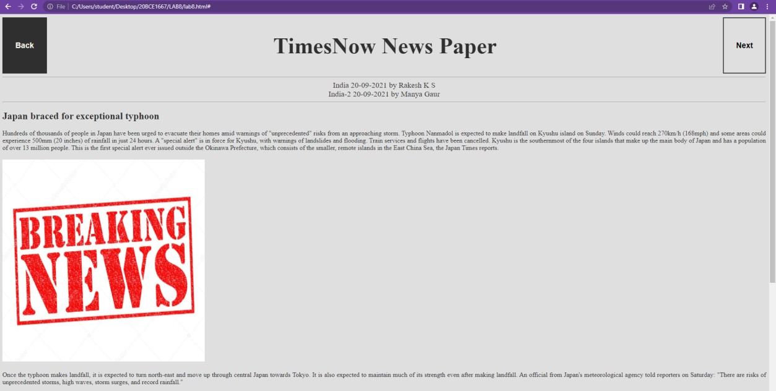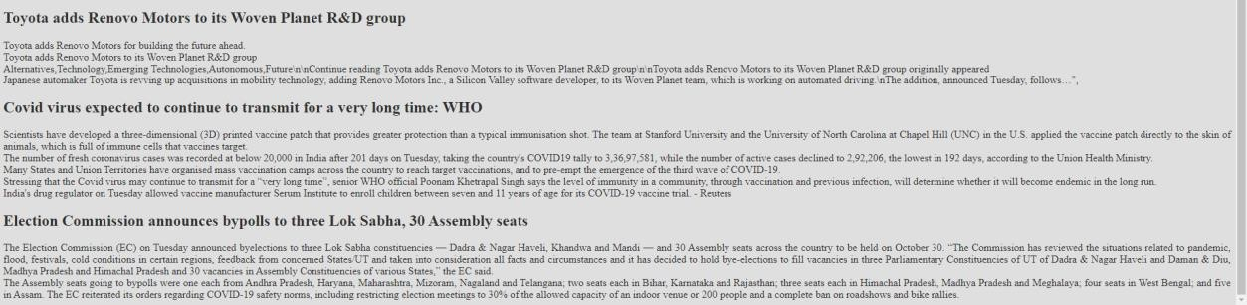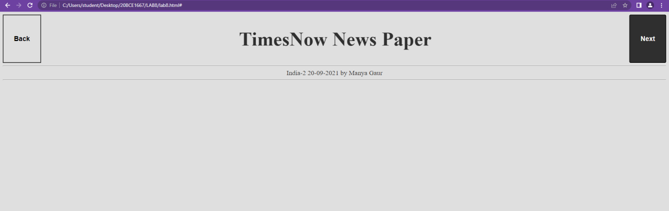

***AJAX:***

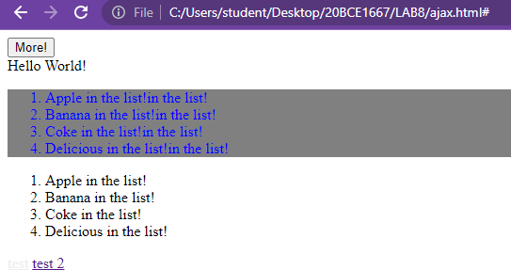

***JQUERY: 1.***

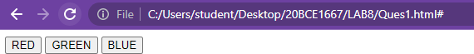



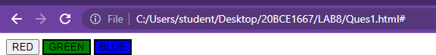



***2.***

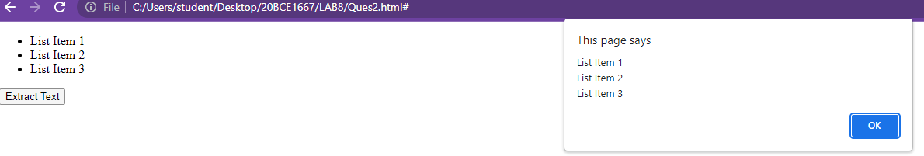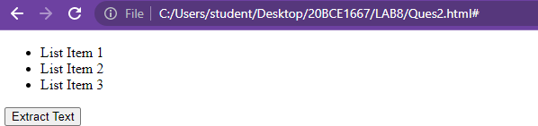

# LAB 8

***INPUT:***

<?php

*/*1. Develop a simple program in PHP, to compute the yearly payment for the following: Initiate the loan amount of Rs.10000 with an interest of 10% per month in the program and compute the yearly payment. Display the result in a web page.*/*

$p = 10000;

$r = 0.1;

$t = 12; *# interest permonth*

$payment = $p*$r*$t; echo('<br />');

echo sprintf("1. Yearly Payment : %d",$payment); echo('<br />');

*/*2. Assume that a mathematician wants to automate an equation in-order to find out the value of the variable ‘y’ for the given equation. Being a programmer, to develop a program using PHP and find the value of ‘y’.*/*

$x = (**int**)readline('Enter x:');

$n = (**int**)readline('Enter n:'); if($n==1)

{

$y = 1+$x;

}

elseif ($n==2)

{

$y = 1+$x/$n;

}

elseif ($n==3)

{

$y = 1+pow($x,$n);

}

else

{

$y = 1+$n;

}

echo('<br />');

echo sprintf('2. The value of [y] = %d',$y); echo('<br />');

*/*3. Develop a PHP program to allot the branch the student opt in engineering stream based on the entrance exam marks they secured :*

*if mark>=90 Computer Science Engineering*

*>=80 mark <90 Mechanical Engineering*

*>=70 mark <80 Civil Engineering*

*else eligible for other engineering branches*/*

echo('<br />');

$marks = (**int**)readline('Enter Marks:'); if($marks>=90)

{

echo('3. Computer Science Engineering');

}

else

{

if($marks>=80)

{

echo('3. Mechanical Engineering');

}

else {

if($marks>=70)

{

echo('3. Civil Engineering');

}

else

{

echo('3. Eligible for other Engineering');

}

}

}

echo('<br />');

*/*4. Develop a PHP program to remove zeros from the given number and display the result in a web page. For example, if the number is 102005 then desired output is 15.*

*(Note: Initiate the input as 102005 in the program)*/*

echo('<br />');

$num = 102005;

echo('4. The new number is : '); echo str_replace("0","",$num); echo ('<br />');

*/*5. Given a four digit number ‘x’, to check whether ‘x’ is divisible by the sum of the digits of ‘x’. A number ‘x’ is said to be divisible by ‘y’, if the remainder is zero when ‘x’ divides ‘y’. Develop a PHP program using do…while loop. For example, the number ‘x’ is 1234 is not divisible by 10, because if we divide ‘1234’ with the sum of its individual digits (1+2+3+4 = 10), then the remainder is not zero.*/*

echo ('<br />');

$x_main = (**int**)readline('Enter 4 digit number "x" : ');

$x_num = $x_main;

$sum=0;

$rem=0; do

{

$rem = $x_num % 10;

$sum = $x_num + $rem;

$x_num = $num/10;

} while($x_num>=0);

if($x_main%$sum == 0)

{

echo ('5. It is possible!!');

}

else

{

echo ('5. It is NOT possible!!');

}

echo ('<br />');

*/*6. A sequence generator generates number from 1. The new number generated is equal to sum*

*of number previously generated and index of the number generated. That is for nth number, n is the index and it is equal to (n-1)th number in sequence + n. 1,1+2, 3+3, 6+4, 10+5,*

*15 + 6, .... Develop a php program to determine the nth number that will be generated by the sequence generator. Use do while loop in php.*/*

echo ('<br />');

echo ('Enter n: ');

$n1 = readline();

$i = 1;

$p = 0; do {

$p = $p+$i;

$i = $i+1;

} while ($i<=$n1);

echo ("6. Nth number generated by sequence is: ".$p.""); echo ('<br />');

*/*7. Develop a simple PHP program using for loop to print the integers from 1 to 1000 omitting those integers which are divisible by 7.*/*

echo ('<br />');

for($j=1;$j<=1000;$j++)

{

$r = $i%7; if($r!=0)

{

echo "7. "."$j"."$nbsp;";

}

}

echo ('<br />');

*/*8. Assume that you are sending the 4 digit ATM PIN to your friend through email. For security purpose, you are encrypting the PIN and sending it. Develop the program in PHP using while loop to inculcate the following steps for the encryption process :*

1. *Reverse the 4 digit PIN.*
2. *In the reversed PIN, add 7 to each digit.*
3. *Replace each digit with remainder value after dividing by 10.*
4. *Swap the first digit with the third digit.*
5. *Swap the second digit with the fourth. Then print the encrypted integer. For example Input(Actual PIN): 4567, then the output (Encrypted PIN): 2143 (Note: Initiate the input as 4567 in the program)*/*

echo ('<br />');

$number = 4567;

$sum = 0; while($number!=0)

{

$sum=$sum*10+(**int**)$number%10;

$number=(**int**)($number/10);

}

$digit1 = ($sum/1000+7)%10;

$digit2 = ($sum%1000/100+7)%10;

$digit3 = ($sum%100/10+7)%10;

$digit4 = ($sum%10+7)%10;

$dn = (**int**)$digit1*10+$digit2+$digit3*1000+$digit4*100; echo "8. ".$dn;

echo ('<br />');

*/*9. ‘Z’ is to be computed as a function of ‘x’ and ‘y’ according to z=3x2+2y3-25.5.*

*Compute the values of z as x varies from -1.5 to 1.5 increments of 0.5 and y varies*

*from 0 to 3 in steps of 1. Develop a PHP program to compute ‘z’ for all pairs of (x,y).*/*

echo ('<br />');

for($x_one=-1.5;$x_one<=1.5;$x_one=$x_one+0.5)

{

for($y_one=0;$y_one<=3.0;$y_one=$y_one+1.0)

{

$z_one=3*$x_one*$x_one+2*$y_one*$y_one-25.5;

echo "9. The value of ".'y'."($x_one,$y_one)"." is "."$z_one"."\n";

}

}

echo ('<br />');

*/*10. A city has a dam of capacity ‘x’ litres, water comes to the dam from ‘n’ places.*

*Given the value of ‘n’ and the quantity of water (in litres and millilitres) that comes from ‘n’ places, Write a PHP code to determine the total amount of water in the dam.*

*Assume that the total quantity of water in the dam, will be always less than the capacity of the dam. For example, if there are three places from which water comes to the dam and the water from place 1 is 2 litres 500 ml, water from second place is 3 litres 400 ml and water from third place is 1 litre 700 ml then the total quantity of water in dam will be 7 litres 600 ml.*/*

echo ('<br />');

echo ('How many number of places? - ');

$nop = readline();

$sml = 0; for($k=0;$k<$nop;$k++)

{

echo "Enter number of liters from place ".($k+1)." : ";

$l = readline();

echo "Enter number of milli-litres from place ".($k+1)." : ";

$ml = readline();

$sml = $sml + ($l)*1000+($ml);

}

$sml2 = $sml;

echo "10. Total Water in Dam is ".intval($sml/1000)." litres and ".intval($sml%1000)." milli-litres.";

echo ('<br />');

?>

***OUTPUT:***

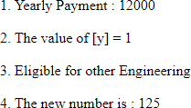

***LAB 9***

**Q1.** Write a PHP program to write 100 integers in to a text file. Read 10 numbers at a time from the file using PHP script and find the numbers which occurs odd number of times.

***CODE:***

***one.php***

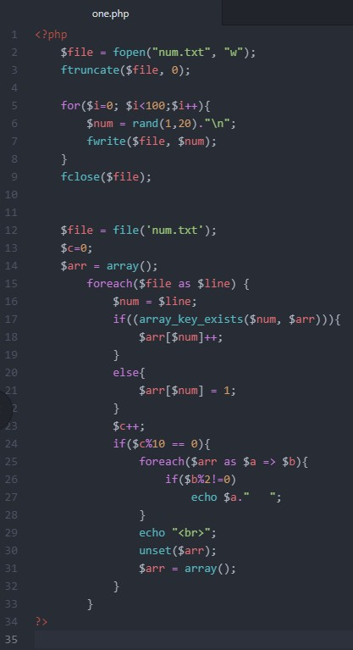

***OUTPUT:***

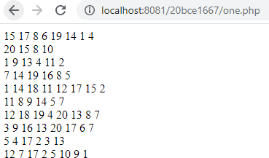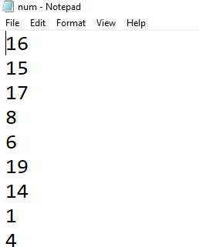

**Q2.** Implement simple currency calculator utility-program, which can be used to calculate currency conversions from dollars to euros. Exchange rates can be found for example on [http://www.x-](http://www.x-rates.com/d/EUR/table.html) [rates.com/d/EUR/table.html](http://www.x-rates.com/d/EUR/table.html). Implement simple HTML-form where user user can input amount of dollars (currency.html) and PHP-script (calculate.php) to calculate currency conversion. PHP-script will read the input values from HTML-form and perform conversion by multiplying dollars with current exchange rate.

***CODE:***

***Currency.html***

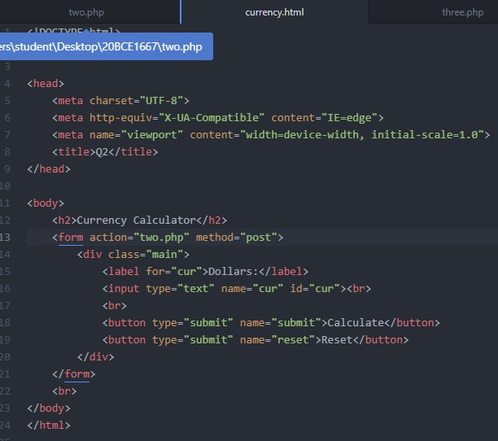

***Two.php***

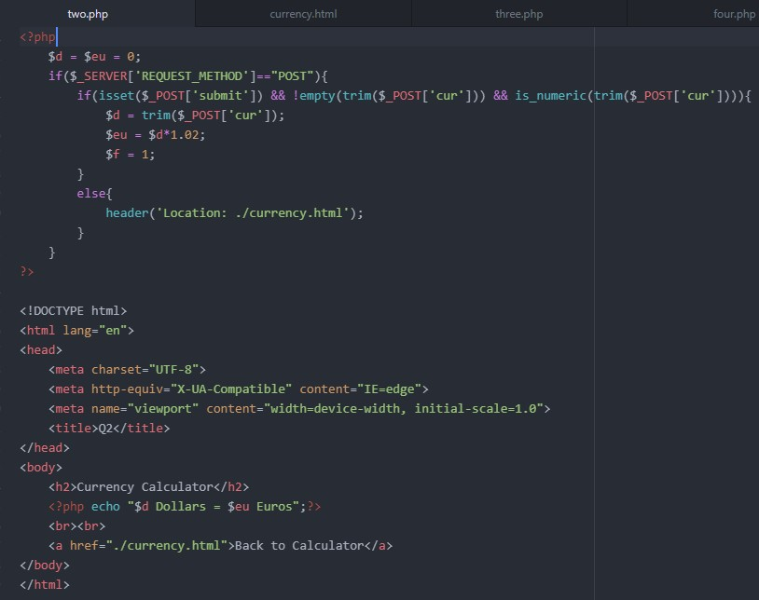

***OUTPUT:***

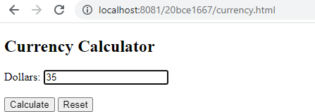

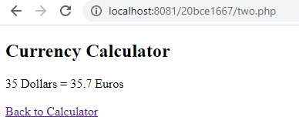

**Q3.** Implement simple application that can be used to sent emails. Use email-function.

***CODE:***

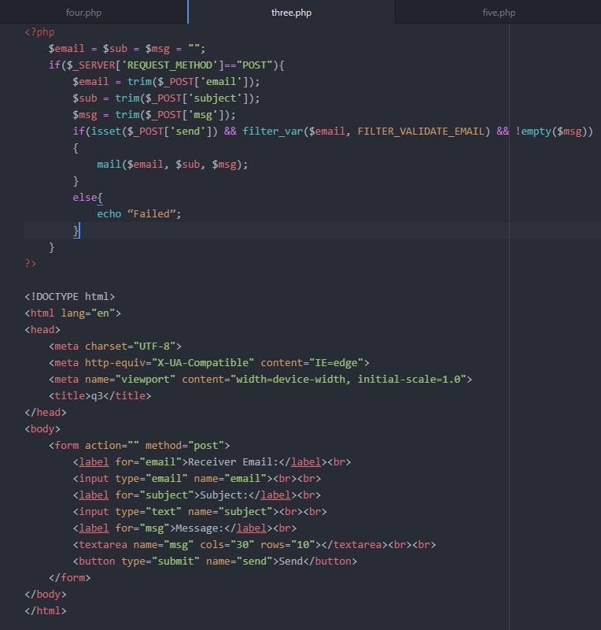

***OUTPUT:***

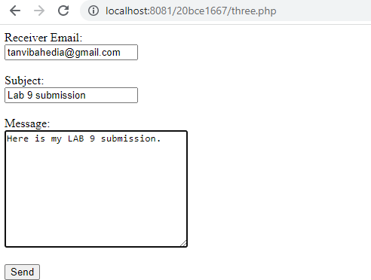

**Q4.** Implement application, which can be used to calculate housing allowance for student. Housing allowance is 80% of reasonable housing cost. Reasonable housing cost is between 33.64�252 �. if cost is under 33.64 � no allowance is paid. If cost is over 252 �, maximun allowance 201.60 � is paid. If cost is between 33.64 � and 252�, allowance is 80%.

***CODE:***

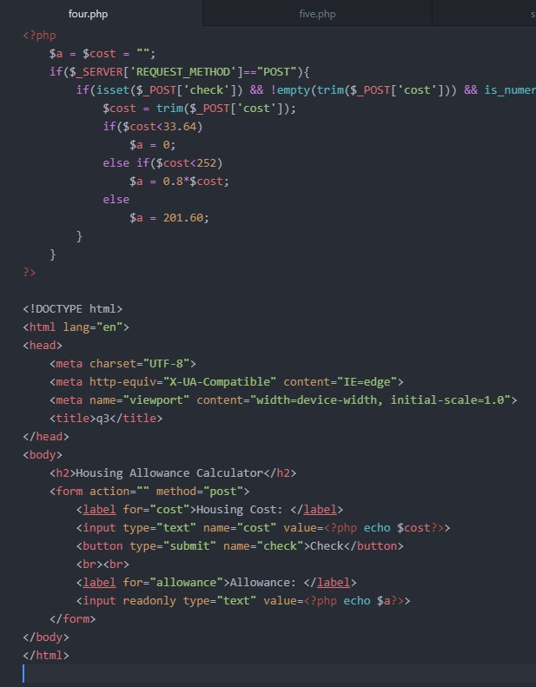

***OUTPUT:***

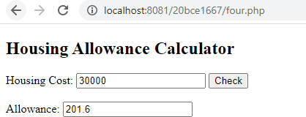

**Q5.** Implement PHP-script (no html is needed) to print out multiplication table of number 10 (see picture below). User for-structure and table html-element.

***CODE:***

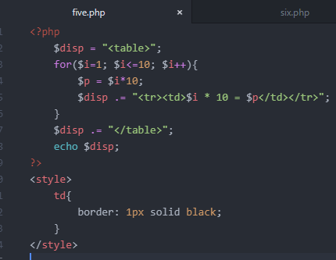

***OUTPUT:***

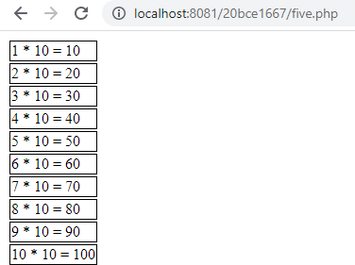

**Q6.** Implement PHP-script to print out times from 8 to 16 to HTML-table.

***CODE:***

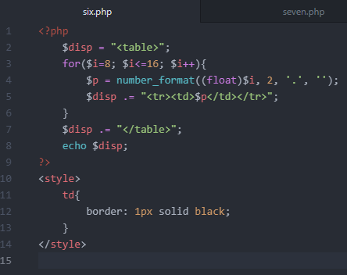

***OUTPUT:***

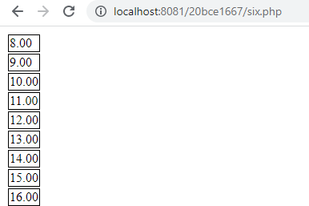

**Q7.** Modify previous exercise so that also day of weeks are printed to page necessary amounts of columns are printed out to each row. Use conditional and loop -structures to implement exercise.

***CODE:***

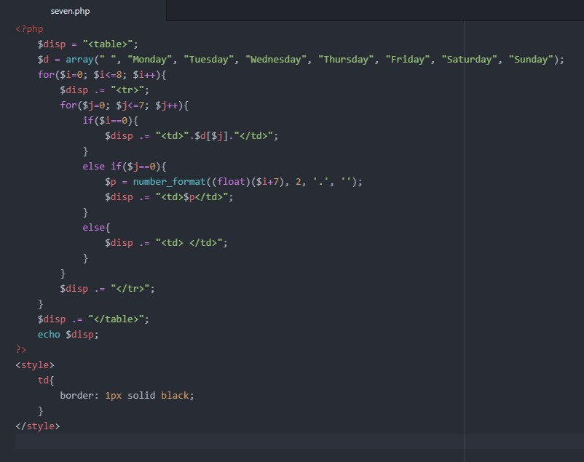

***OUTPUT:***

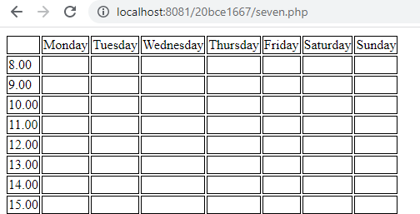

**LAB 10**

**AIM:** To execute XML and XSL

**PROCEDURE:**

* 1. Save xml and xsl in .xml and .xsl files.
  2. Javascript can make AJAX calls to xml.
  3. XSL can be used to display xml content with style.

<!DOCTYPE html>

<html>

<body>

<form>

<input type = "text" id = "word">

<input type = "button" value = "Search Thesaurus" onclick="ajaxlook()">

</form>

Synonyms are: <p id="syn" style = "display: inline-block;"></p>

<br> Antonyms are: <p id="ant" style = "display: inline-block;"></p>

<script> function ajaxlook() { var word = document.getElementById('word').value;

var xhttp = new XMLHttpRequest(); xhttp.onreadystatechange

= function() { if (this.readyState == 4 && this.status == 200) { myFunction(this, word);

} }; xhttp.open("GET",

"books.xml", true); xhttp.send(); }

function myFunction(xml, word)

{ var xmlDoc = xml.responseXML;

document.getElementById("syn").innerHTML = xmlDoc.getElementsByTagName(word)[0].childNodes[1].innerHTML;

//document.getElementById("ant").innerHTML = xmlDoc.getElementsByTagName(word); document.getElementById("ant").innerHTML = xmlDoc.getElementsByTagName(word)[0].childNodes[3].innerHTML

}

</script>

</body>

</html>

**book.xml**

<thesaurus>

<agree>

<synonyms>Consent, Permit</synonyms>

<antonyms>Disagree, Refuse</antonyms>

</agree>

<fragile>

<synonyms>Weak, Infirm</synonyms>

<antonyms>Enduring, Tough</antonyms>

</fragile>

</thesaurus>

**Output**

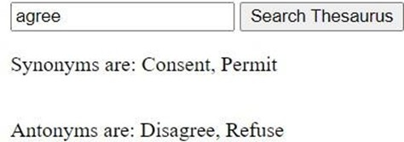

**Display the employee number and name of employees with salary greater than Rs. 20000 with XSL**

**Code emp.xml**

<?xml version="1.0" encoding="UTF-8"?>

<?xml-stylesheet type="text/xsl" href="index2.xsl"?>

<employeelist>

<employee>

<empid>10001</empid>

<name>Lina</name>

<salary>10000</salary>

</employee>

<employee>

<empid>10002</empid>

<name>Shakti</name>

<salary>21000</salary>

</employee>

<employee>

<empid>10003</empid>

<name>Sankaran</name>

<salary>15000</salary>

</employee>

<employee>

<empid>10004</empid>

<name>Rajani</name>

<salary>20000</salary>

</employee>

<employee>

<empid>10005</empid>

<name>Ritika</name>

<salary>11000</salary>

</employee>

<employee>

<empid>10006</empid>

<name>Pratik</name>

<salary>5000</salary>

</employee>

<employee>

<empid>10007</empid>

<name>Lal</name>

<salary>8000</salary>

</employee>

</employeelist>

**index2.xsl**

<?xml version="1.0" encoding="UTF-8"?>

<xsl:stylesheet version="1.0" xmlns:xsl="<http://www.w3.org/1999/XSL/Transform>">

<xsl:template match="/">

<html>

<body>

<h2>Employees earning more that 12000</h2>

<table border="1">

<tr bgcolor="#9acd32">

<th>Emp ID</th>

<th>Name</th>

</tr>

<xsl:for-each select="employeelist/employee">

<xsl:if test="salary > 12000">

<tr>

<td><xsl:value-of select="empid"/></td>

<td><xsl:value-of select="name"/></td>

</tr>

</xsl:if>

</xsl:for-each>

</table>

</body>

</html>

</xsl:template>

</xsl:stylesheet>

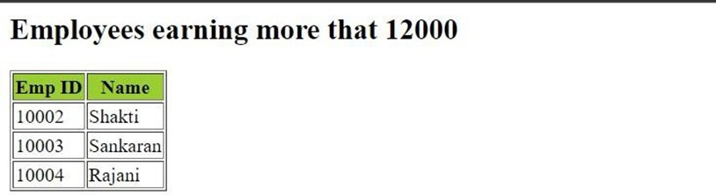**Output**

**Results :** Thus, we have implemented XSL and XML.

**AIM**

**LAB 11**

To execute XML, PHP and database connectivity.

#### Procedure

1. Save xml and xsl in .xml and .xsl files.
2. Javascript can make AJAX calls to xml.
3. XSL can be used to display xml content with style.

#### Questions

###### Payroll information of a company using XML, DTD and CSS

**index.html**

*<!DOCTYPE html>* <head>

<link rel="stylesheet" href="styles.css">

</head>

<html>

<body>

<div class="centering">

<form>

Choose a designation from the list below <select name="desig" id="desig">

<option val = '0'>Select designation</option>

<option val = 'CEO'>CEO</option>

<option val = 'Lead'>Lead</option>

<option val = 'SDE'>SDE</option>

</select>

</form>

<input type = "button" value = "Search Salary" onclick="ajaxlook()">

</form>

<br>

<p id="sal"></p>

<br>

</div>

<script> function ajaxlook()

{

var word = document.getElementById('desig').value; var xhttp = new XMLHttpRequest(); xhttp.onreadystatechange = function() { if (this.readyState == 4 && this.status == 200) { myFunction(this, word);

}}; xhttp.open("GET", "payroll.xml", true); xhttp.send(); }

function myFunction(xml, word) { var xmlDoc = xml.responseXML;

document.getElementById("sal").innerHTML = "Salary is " + xmlDoc.getElementsByTagName(word)[0].childNodes[1].innerHTML; }

</script>

</body>

</html>

**styles.css**

.centering { display : flex ; align-items : center ; justify-content : center ; flex-direction: column;

}

**Note.dtd**

*<!DOCTYPE*

*note [*

*<!ELEMENT payroll (CEO, Lead, SDE)>*

*<!ELEMENT CEO (#PCDATA)>*

*<!ELEMENT Lead (#PCDATA)>*

*<!ELEMENT SDE (#PCDATA)>*

]>

**payroll.xml**

*<?xml version="1.0" encoding="UTF-8"?>*

*<!DOCTYPE note SYSTEM "Note.dtd">*

<payroll>

<CEO>

<salary>100000</salary>

</CEO>

<Lead>

<salary>75000</salary>

</Lead>

<SDE>

<salary>50000</salary>

</SDE>

</payroll>

* + 1. **Output**

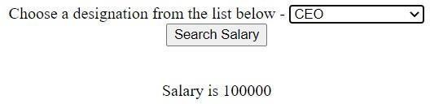

###### Online bookstore using data islands - XML. HTML. DTD, CSS

**index.html**

<html>

<head>

<link rel="stylesheet" href="styles.css">

</head>

<body>

<div class=centering>

<h1>Online Bookstore</h1>

</div>

<xml>

<!DOCTYPE Note SYSTEM "Note.dtd">

<div class=centering>

<table border=3>

<tr>

<th>Name</th>

<th>Author</th>

<th>Stock available</th>

<th colspan="2">Actions</th>

</tr>

<book>

<tr>

<td>

<name>Harry Potter</name>

</td>

<td>

<author>JK Rowling</author>

</td>

<td>

<stock>125 paperback</stock>

</td>

<td><button>Add to Cart</button></td>

<td><button>Buy Now</button></td>

</tr>

</book>

<book>

<tr>

<td>

<name>An Era of Darkness</name>

</td>

<td>

<author>Shashi Tharoor</author>

</td>

<td>

<stock>15 paperback</stock>

</td>

<td><button>Add to Cart</button></td>

<td><button>Buy Now</button></td>

</tr>

</book>

<book>

<tr>

<td>

<name>Playing it my Way</name>

</td>

<td>

<author>S. Tendulkar</author>

</td>

<td>

<stock>50 paperback</stock>

</td>

<td><button>Add to Cart</button></td>

<td><button>Buy Now</button></td>

</tr>

</book>

</table>

</div>

</xml>

</body>

</html>

**Note.dtd**

*<!DOCTYPE*

*Note [*

*<!ELEMENT book (name, author, stock)>*

*<!ELEMENT name (#PCDATA)>*

*<!ELEMENT author (#PCDATA)>*

*<!ELEMENT stock (#PCDATA)>* ]>

**styles.css**

.centering { display : flex ; align-items : center ; justify-content : center ; flex-direction: column;

}

.books { border: 1px solid black; padding: 2px;

}

**Output**

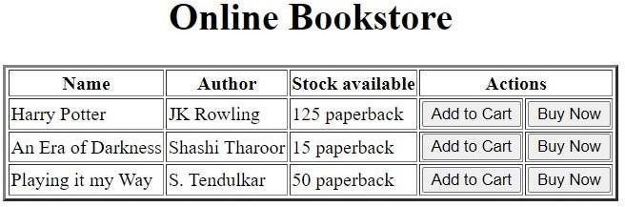

###### Menu items using database connectivity

**menus*.php***

<html>

<head>

<link hre[f="h](https://cdn.jsdelivr.net/npm/bootstrap%405.2.2/dist/css/bootstrap.min.css)ttp[s://cdn.jsdelivr.net/npm/bootstrap@5.2.2/dist/css/bootstrap.min.css"](https://cdn.jsdelivr.net/npm/bootstrap%405.2.2/dist/css/bootstrap.min.css) rel="stylesheet" />

</head>

<body >

<h1 style = " margin: 10px">Menu Items</h1>

<br>

<form action="" method="POST"> Choose which menu you would like to see:

<select name="ch" id="ch">

<option value="0">Select</option>

<option value="1">Veg Menu</option>

<option value="2">Non-Veg Menu</option>

<option value="3">Show all items</option>

</select>

<input type="submit" name="submit" value="Submit">

</form> <?php

if (isset($_POST['submit'])) {

$conn = mysqli_connect ('localhost:3307', 'root','','test1');

$ch = $_POST['ch']; if ($ch == 1)

$sql = 'SELECT * from menu where veg = "yes"'; else

$sql = 'SELECT * from menu';

$result = $conn -> query ($sql); echo '

<table class="table table-striped" style="margin:10px; width: 250px">

<thead>

<tr>

<th>Item</th>

<th>Price</th>

</tr>

</thead>

<tbody>';

while ($row = $result->fetch_assoc())

{

echo "

<tr>

<th>".$row['item']."</th>

<th>".$row['price']."</th>

</tr> ";

}

echo "</tbody></table>";}?>

</body>

</html>

**Output**

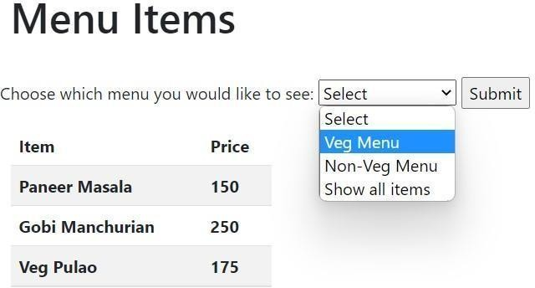

###### PHP Sessions

**session.php**

*<?php* session_start();

if (isset($_SESSION)) echo "Session started";

else die("Session error"); $_SESSION['Name'] = "Timothy"; session_unset(); echo "<br> Session status is ".session_status(); session_destroy(); echo "<br> Session status is ".session_status();

*?>*

**Output**

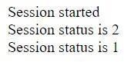

###### PHP Cookies

**cookie.php**

*<?php*

$cookie_name = "user"; $cookie_value = "IWP"; setcookie($cookie_name,

$cookie_value, time() + (86400 * 3), "/"); *// 86400 = 1 day*

if(isset($_COOKIE[$cookie_name])) {

echo "Cookie '" . $cookie_name . "' is set!<br>"; echo "Value is: " .

$_COOKIE[$cookie_name];

} setcookie("user", "", time() - 3600); if (count ($_COOKIE > 0) {

echo "Cookies are enabled.";

} else { echo "Cookies are disabled.";

}

*?>*

**Output**



###### Extract .txt data with .php file

**hobbies.txt**

**index.html**

*<!DOCTYPE html>*

<html>

<body>

<h1>Load Data from text file </h1>

<button type="button" onclick="loadDoc()">Read hobbies.txt</button> <p id = "demo"></p>

<script> function loadDoc() {

var xhttp = new XMLHttpRequest();

xhttp.onreadystatechange = function () {

if (this.readyState == 4 && this.status == 200) { var allText = this.responseText; document.getElementById("demo").innerHTML = xhttp.responseText;

}

};

xhttp.open("GET", "hobbies.txt", true); xhttp.send();

}

</script>

</body>

</html>

**Output**

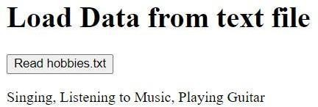

###### AJAX using XML

**index.html**

*<!DOCTYPE html>*

<html>

<body>

<h2>Restaurant List</h2>

<input type = "button" value = "View Restaurants" onclick="ajaxlook()">

<p id="r1"></p>

<p id="r2"></p>

<script> function ajaxlook()

{

var xhttp = new XMLHttpRequest(); xhttp.onreadystatechange = function() { if (this.readyState == 4 && this.status == 200) { myFunction(this); }

};

xhttp.open("GET", "rest.xml",

true); xhttp.send(); }

function myFunction(xml) { var xmlDoc = xml.responseXML;

console.log (xmlDoc.getElementsByTagName('restaurant')) document.getElementById("r1").innerHTML = xmlDoc.getElementsByTagName('restaurant')[0].children[0]. + xmlDoc.getElementsByTagName('restaurant')[0].children[1].innerHTML +', ' + xmlDoc.getElementsByTa

+ 'Ph: ' + xmlDoc.getElementsByTagName('restaurant')[0].children[3].innerHTML;

document.getElementById("r2").innerHTML = xmlDoc.getElementsByTagName('restaurant')[1].children[0]. + xmlDoc.getElementsByTagName('restaurant')[1].children[1].innerHTML +', ' + xmlDoc.getElementsByTa

+ 'Ph: ' + xmlDoc.getElementsByTagName('restaurant')[1].children[3].innerHTML;

}

</script>

</body>

</html>

**rest.xml**

*<?xml version="1.0" encoding="UTF-8"?>*

*<?xml-stylesheet type="text/xsl" href="style.xsl"?>*

<restaurants>

<restaurant>

<name>La Pasteria</name>

<address>13 Alonisou Street, Patras, 261 35</address>

<cuisine>Italian</cuisine>

<phoneno>2610325833</phoneno>

</restaurant>

<restaurant>

<name>Kalamarakia</name>

<address>21 Poseidonos Street, Patras, 264 45</address>

<cuisine>Greek</cuisine>

<phoneno[html]>2610428066</phoneno>

</restaurant>

</restaurants>

**style.xsl**

*<?xml version="1.0" encoding="UTF-8"?>*

<xsl:stylesheet version="1.0" xmlns:xsl=["h](http://www.w3.org/1999/XSL/Transform)t[tp://www.w3.org/1999/XSL/Transform](http://www.w3.org/1999/XSL/Transform)">

<xsl:template match="/">

<html>

<body>

<h2>Restaurant List</h2>

<table border="1">

<tr bgcolor="#9acd32">

<th>Name</th>

<th>Adress</th>

<th>Cuisine</th>

<th>PhoneNo</th>

</tr>

<xsl:for-each select="restaurants/restaurant">

<tr>

<td><xsl:value-of select="name"/></td>

<td><xsl:value-of select="address"/></td>

<td><xsl:value-of select="cuisine"/></td>

<td><xsl:value-of select="phoneno"/></td>

</tr>

</xsl:for-each

>

</table>

</body>

</html>

</xsl:template>

</xsl:stylesheet>

**Output**

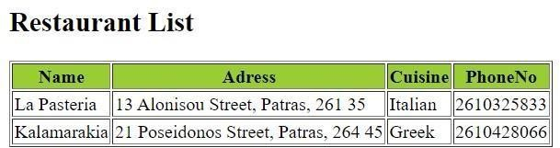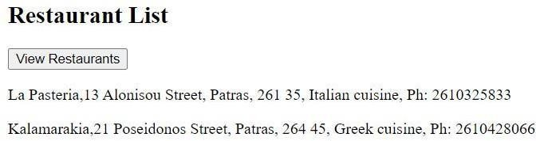

**Results**: Thus, we have utilised XML, PHP and database connectivity.

LAB 12

**Aim:** To work on NodeJS and MongoDB

**Installing NodeJS**

**Procedure**

* + - 1. Download Node.js installer from [http://nodejs.org](http://nodejs.org/)
      2. Node.js installer installs the necessary files on your PC to get Node.js up and running
      3. Node.js installation location
      4. To verify whether Node.js is installed and working execute the command “node” in command prompt

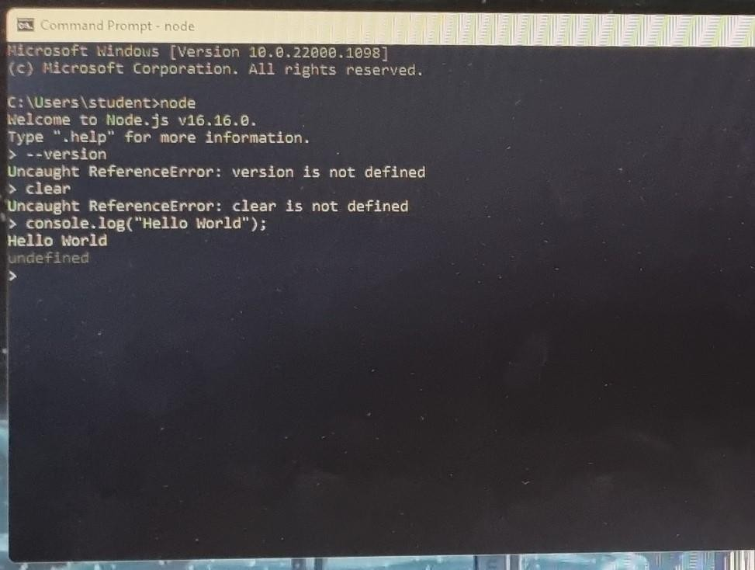**Output**

Installing MongoDB

**Procedure**

1. Download MongoDB installer from [http://mongodb.com](http://mongodb.com/)
2. The installer installs the necessary files on your PC to get MongoDB up and running
3. In the folder C :Program Files MongoDB, create 2 Folders
4. Name first folder as data, Name other folder as log
5. Create another folder inside ’data’ and name it as db. Data stored here
6. To configure Mongodb, you can type

- mongod --directoryperdb -- dbpath C:>Program Files>MongoDB>data>db --logpath C>Program Files>MongoDB>log>mongo.log

--logappend --rest --install

1. To verify whether MongoDB is installed and working execute the command “mongo” in command prompt

**Output**

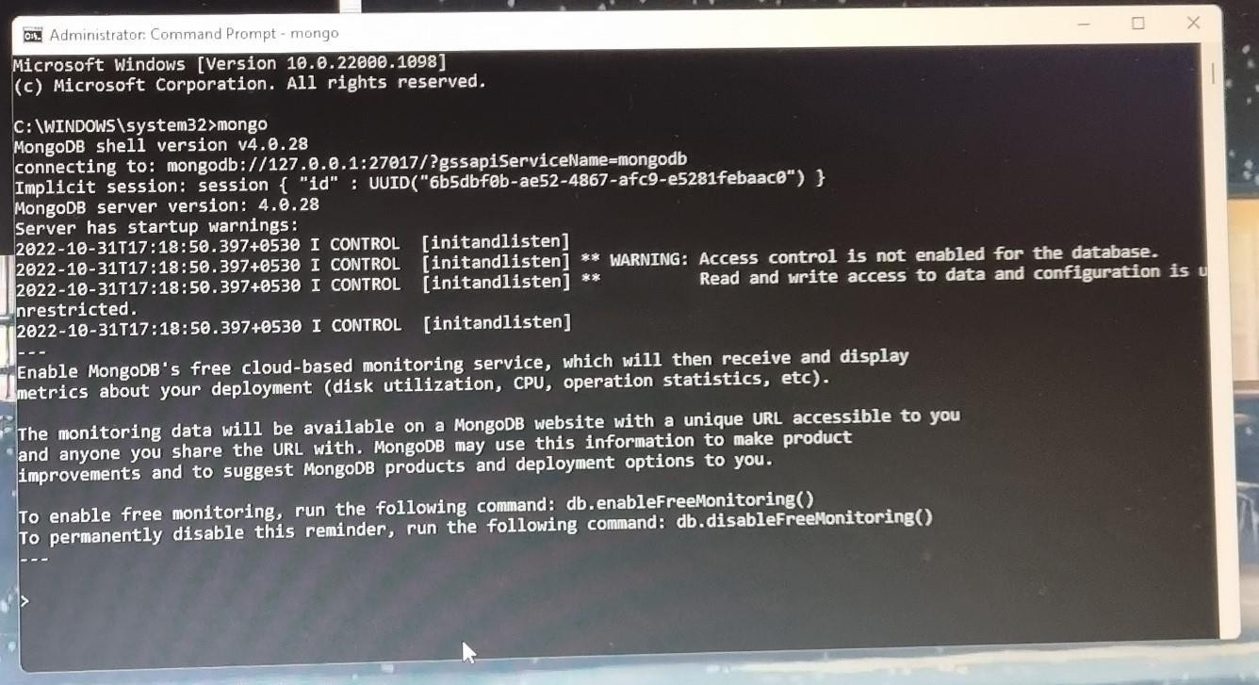

**Results:** Thus, we have been introduced to NodeJS and MongoDB.

2